A Project Report on

**GET DOCTORS**

*Submitted*

In Partial Fulfillment of the Requirements

for the Degree Of

**Master of Science**

**[Computer Applications & Information Technology]-VI**

**Submitted to**



**Department of Computer Science,**

**HEMCHANDRACHARYA**

**NORTH GUJARAT UNIVERSITY**

|  |  |
| --- | --- |
| **Submitted By:**  Sahil Patel (176)  Kevin Patel (105) | **Project Guide**  Dr. Hinal Prajapati  Dr. Tushar Parikh |

**May, 2024**

**Acknowledgement**

I have taken efforts in this project. However, it would not have been possible without the kind support and help of many individuals and organizations.

I would like to extend my sincere thanks to all of them.

I am highly indebted to Dr. Hinal Prajapati and Dr. Tushar Parikh sir for their guidance and constant supervision as well as for providing necessary information regarding the project & also for their support in completing the project.

I would like to express my gratitude towards my parents & member of Department of Computer Science for their kind cooperation and encouragement which help me in completion of this project.

I would like to express my special gratitude and thanks to industry persons for giving me such attention and time.

Thank you to all person involve in this project.

**Thank You,**

**Patel Sahil**

**Patel Kevin**

**Table Of Content (Index Page) :-**

**Chapter 1 :- Introduction**

* 1. Project Profile
  2. Company Profile
  3. Project Definition

**Chapter 2 :- System Analysis**

2.1 Hardware & Software Configuration

2.2 Requirements Analysis

2.3 Existing System

2.4 Need For New System

2.5 Module Of System

**Chapter 3 :- System Design**

3.1 DFD ( Data Flow Diagram )

3.2 DD ( Data Dictionary )

3.3 ER Diagram

**Chapter 4 :- Interface**

4.1 Screenshots

4.2 User Module

4.3 Admin Module

**Chapter 5 :- Conclusion & Future Work**

**Chapter 6 :- References**

**Chapter 1 🡺 Introduction**

The initiative we're discussing aims to revolutionize healthcare accessibility through digital solutions. By leveraging technology, it seeks to connect patients with healthcare professionals seamlessly, addressing barriers like distance and limited availability. Through telemedicine and digital platforms, individuals can schedule appointments, consult with doctors remotely, and access medical information conveniently. Ultimately, this initiative aims to enhance healthcare outcomes and improve the patient experience by making quality medical care more accessible to all.

This project is all about making it easier for people to see a doctor, especially if they live far away or have trouble getting to a clinic. It uses technology like apps or websites to connect patients with doctors online. This means you can talk to a doctor from the comfort of your own home! It's like having a virtual doctor's appointment. The goal is to make sure everyone can get the medical help they need, no matter where they are.

* 1. **:- Project Profile**

|  |  |
| --- | --- |
| **Project Title** | GET DOCTORS |
| **Front End** | HTML, CSS, JavaScript, Bootstrap, jQuery |
| **Front End Tool** | VS Code |
| **Back End** | MySQL |
| **Back End Tool** | Wamp Server, VS Code |
| **Coding Language** | PHP |
| **Member Name** | Patel Sahil  Patel Kevin |
| **Project Duration** | 3 Months |
| **Internal Guide Name** | Dr. Hinal Prajapati  Dr. Tushar Parikh |
| **External Guide Name** |  |

**1.2 :- Company Profile**

**1.3 :- Project Definition**

**Project Title :** Get Doctors

**Definition :** The "Get Doctors" project aims to develop and implement a digital platform that connects patients with healthcare professionals for remote consultations and medical assistance. Through this platform, users will be able to schedule appointments, consult with doctors online, and access medical information conveniently from their devices.

**Objectives :** The "Get Doctor" project aims to enhance healthcare accessibility by connecting patients with remote consultations. It seeks to improve patient experience, streamline appointment scheduling, and ensure quality healthcare delivery through digital platforms.

**Scope :** The project encompasses the development of a user-friendly digital platform for scheduling appointments and conducting remote consultations. It includes integration of telemedicine features, compliance with regulatory standards, and marketing efforts to attract users and healthcare professionals.

**Requirements :** Technical requirements involve building a secure and scalable platform with telemedicine features and compatibility across devices. Regulatory compliance includes adherence to healthcare regulations and licensing of healthcare professionals. User experience considerations entail an intuitive interface and accessibility features. Security measures encompass encryption protocols and data protection.

**Deliverables :** The project delivers a functional digital platform, onboarded healthcare professionals, comprehensive documentation, marketing materials, and ongoing technical support.

**Chapter 2 🡺 System Analysis**

**2.1 :- Hardware & Software Configuration**

**(1) Hardware Requirements**

1. Hard Disk : 60 up to 120 GB or higher

2. Keyboard : 101 Keys

3. Mouse

4. RAM : 4 GB or Above

5. Processor : 12th Gen Intel(R) Core(TM) i5-12450H

**(2) Software Requirements**

1. Front End : HTML, CSS, JavaScript, Bootstrap, jQuery

2. Back End : PHP, MySQL

3. Document Tools : Microsoft Word, Power Point

4. Operating System : Windows 11

**2.2 :- Requirements Analysis**

**Functional Requirements :-** The platform must support appointment scheduling, secure remote consultations, and provide access to medical records and prescription management tools.

**Technical Requirements :-** Ensuring scalability and security is paramount, along with compatibility across various devices and integration with existing electronic health record (EHR) systems.

**User Experience Requirements :-** User satisfaction relies on an intuitive interface, accessibility features, and options for personalization to cater to diverse user needs and preferences.

**Performance Requirements :-** Fast response times, high availability, and reliability are crucial, alongside sufficient bandwidth to support quality video conferencing during consultations.

**Integration with Healthcare Ecosystem :-** Integration with pharmacies for prescription fulfillment, collaboration with insurance providers for billing processes, and partnerships with healthcare facilities for referrals and coordination of care are vital for a comprehensive healthcare ecosystem.

**2.3 :- Existing System**

**Traditional Healthcare Delivery :** Currently, patients typically visit physical healthcare facilities such as hospitals, clinics, or doctor's offices for medical consultations, which can be time-consuming and inconvenient, especially for those with mobility issues or living in remote areas.

**Limited Access to Specialists :** Access to specialized medical care may be limited, particularly in rural or underserved areas, requiring patients to travel long distances or wait extended periods for appointments with specialists.

**Lack of Remote Consultation Options :** There is a lack of widespread adoption of telemedicine solutions, which could provide remote consultation options for patients, reducing the need for in-person visits and improving access to medical care, especially during emergencies or times of restricted mobility.

**Fragmented Medical Records :** Patient medical records are often stored in fragmented systems across different healthcare providers, leading to inefficiencies in accessing and sharing critical medical information, which can impact the quality and continuity of care.

**Limited Availability of Healthcare Professionals :** There may be shortages of healthcare professionals, particularly in certain specialties or geographic regions, resulting in long wait times for appointments and delays in receiving necessary medical attention.

**2.4 :- Need For New System**

**Enhanced Accessibility :** A new system is needed to improve access to healthcare services, especially for individuals in remote or underserved areas who face challenges in accessing traditional healthcare facilities. By providing remote consultation options, the new system can bridge geographical barriers and ensure timely access to medical care.

**Efficient Utilization of Resources :** Implementing a new system with telemedicine capabilities can optimize resource utilization by reducing the burden on physical healthcare facilities, minimizing wait times for appointments, and reallocating resources to areas of greatest need. This efficiency can enhance the overall effectiveness of the healthcare system.

**Improved Patient Experience :** Introducing a new system that offers convenient remote consultations and streamlined appointment scheduling can significantly enhance the patient experience. Patients will benefit from reduced travel time and waiting room congestion, as well as increased flexibility in accessing medical care, leading to greater satisfaction and better health outcomes.

**Response to Changing Healthcare Landscape:** In response to evolving healthcare needs, including demographic shifts, technological advancements, and the recent challenges posed by public health crises, the implementation of a new system with telemedicine capabilities is essential to modernize healthcare delivery and ensure resilience in the face of future challenges.

**2.5 :- System Module**

**2.5.1 : Patient**

2.5.1.1 Registration / Login

2.5.1.2 Show All Doctors

2.5.1.3 Book Appointment

2.5.1.4 Show Appointment

2.5.1.5 Generate Appointment Report

2.5.1.6 Update, View, Delete Account

**2.5.2 : Doctor**

2.5.2.1 Login

2.5.2.2 Show Patients

2.5.2.3 Show Appointment

2.5.2.4 Generate Appointment Report

2.5.2.5 Update, View, Delete Account

**2.5.3 : Admin**

2.5.3.1 Login

2.5.3.2 Add Doctors

2.5.3.3 Show All Patients

2.5.3.4 Generate Patients Report

2.5.3.5 Show All Doctors

2.5.3.6 Generate Doctors Report

2.5.3.7 Show All Appointments

2.5.3.8 Generate Appointments Report

**Chapter 3 🡺 System Design**

**3.1 :- DFD Diagram**

**CONTEXT LEVEL DFD : LEVEL 0**

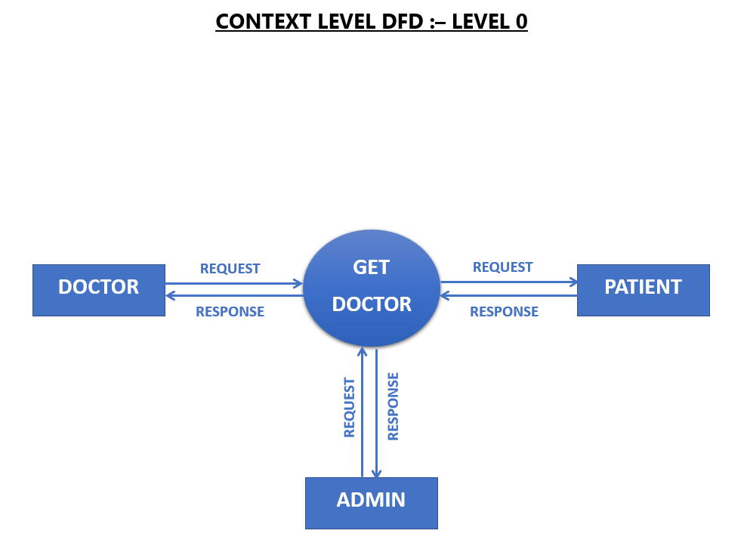

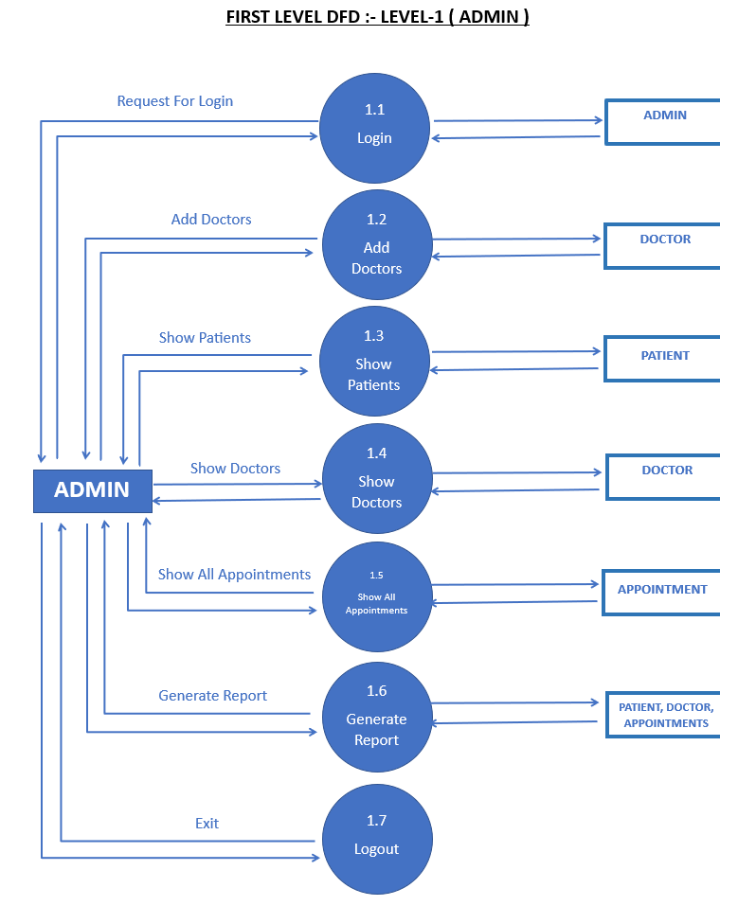

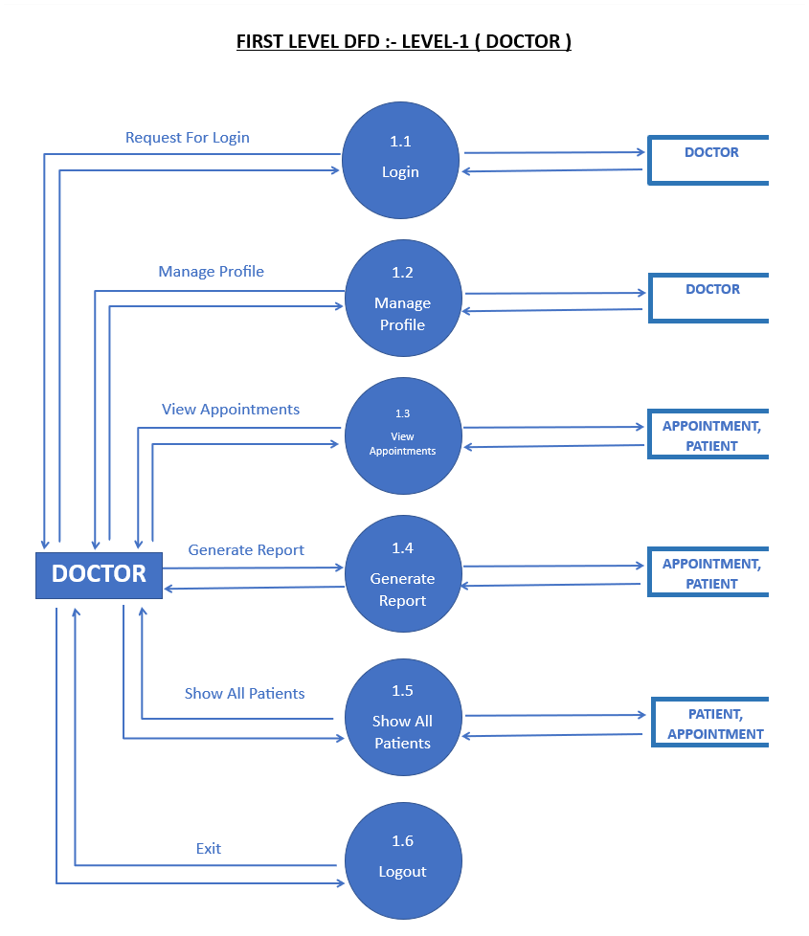

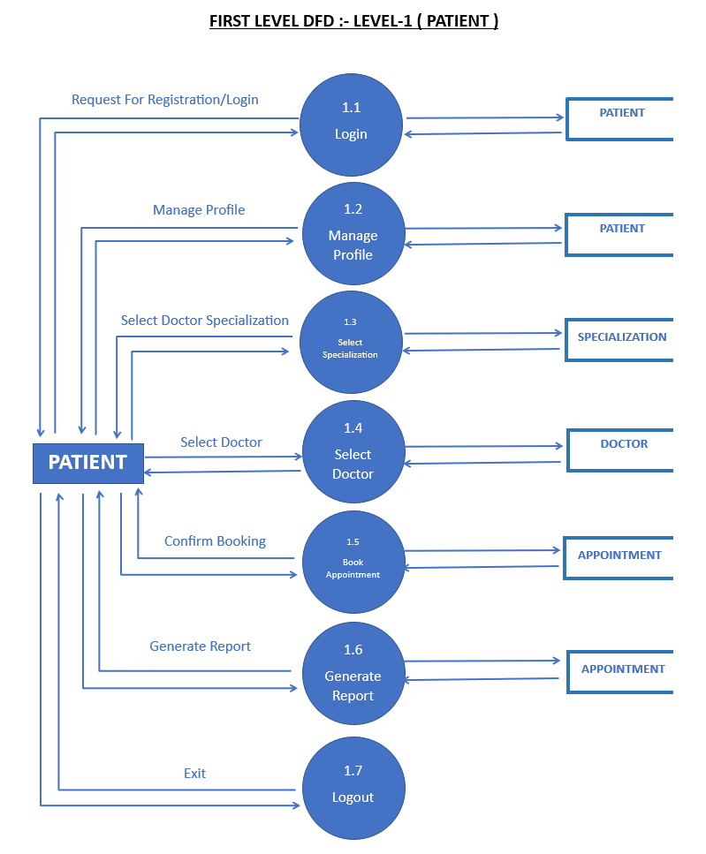

**3.2 :- Data Dictionary**

Specialization

Admin

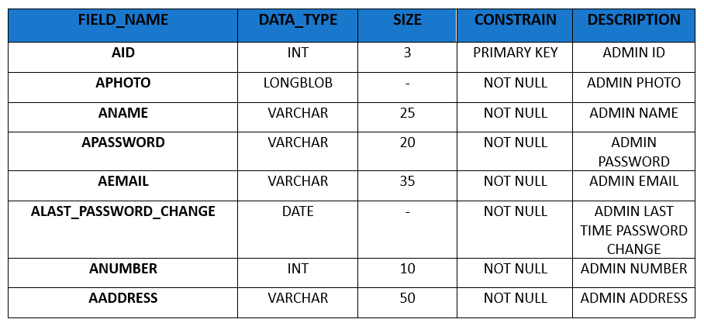

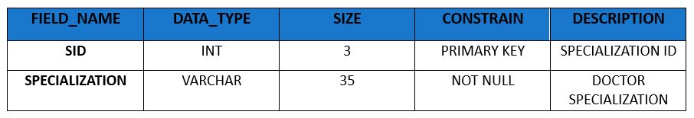

Doctor

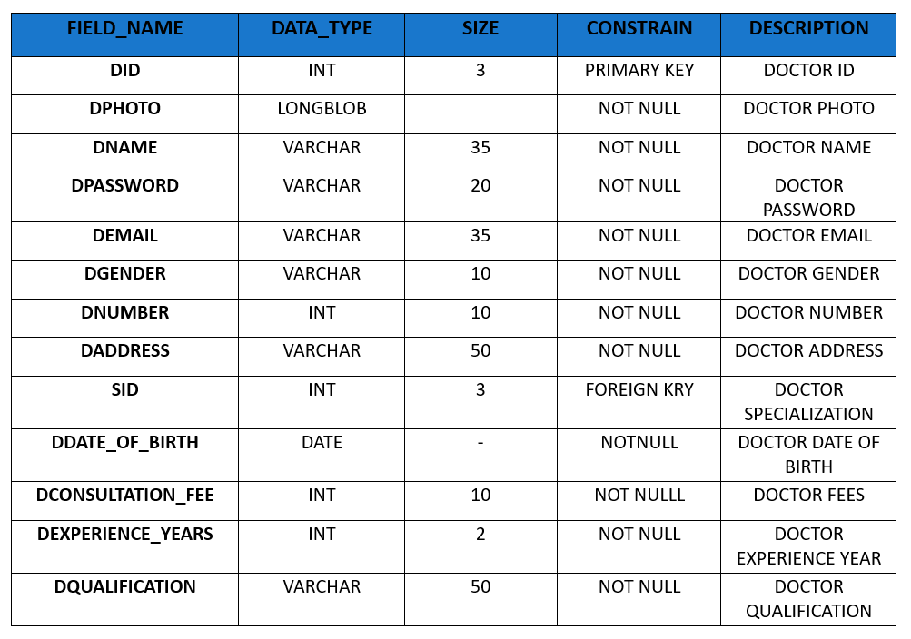

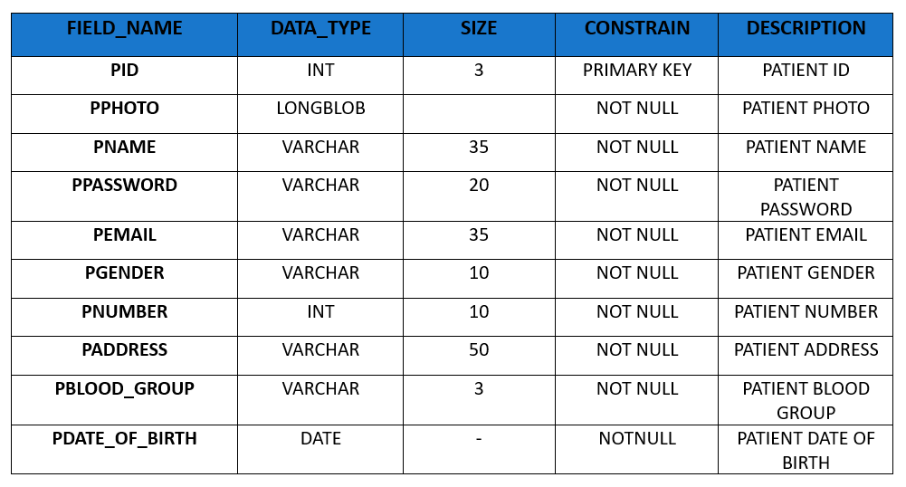Patient

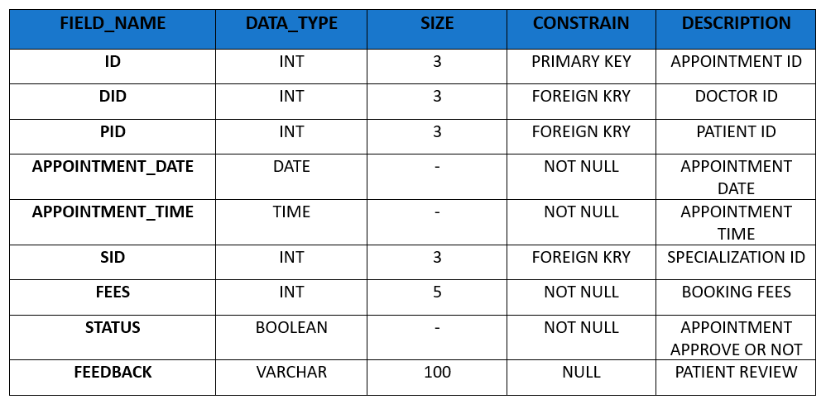Appointment

**3.3 :- ER Diagram**

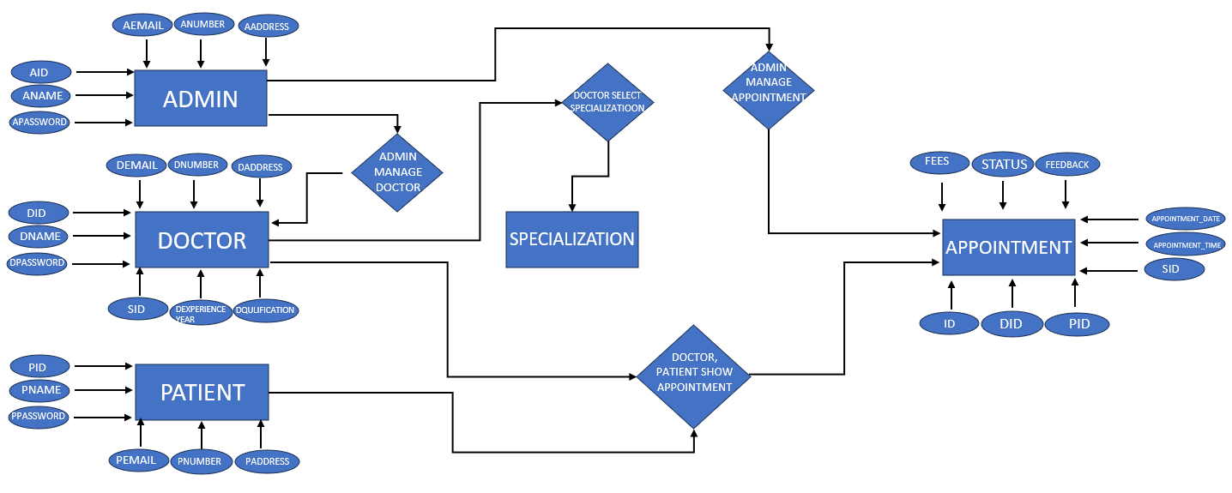

**Chapter 4 🡺 Interface Design**

**4.1 :- Screenshot**

**Home**

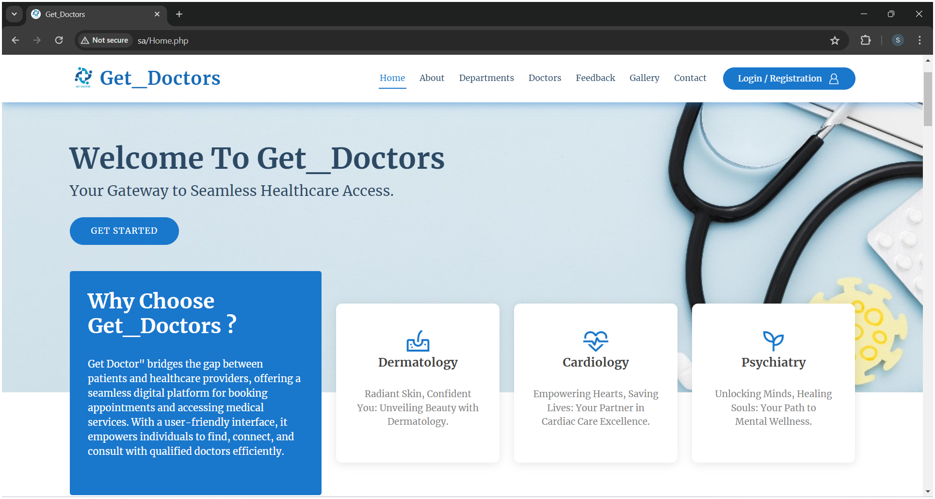

**About**

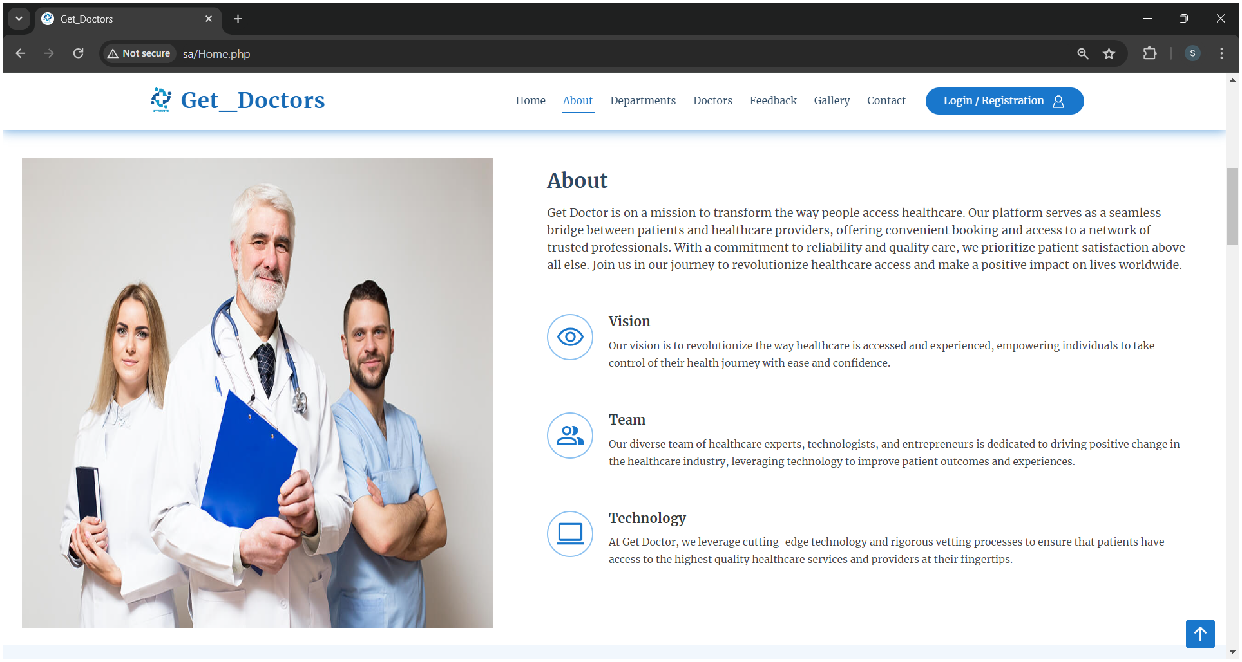

**Departments**

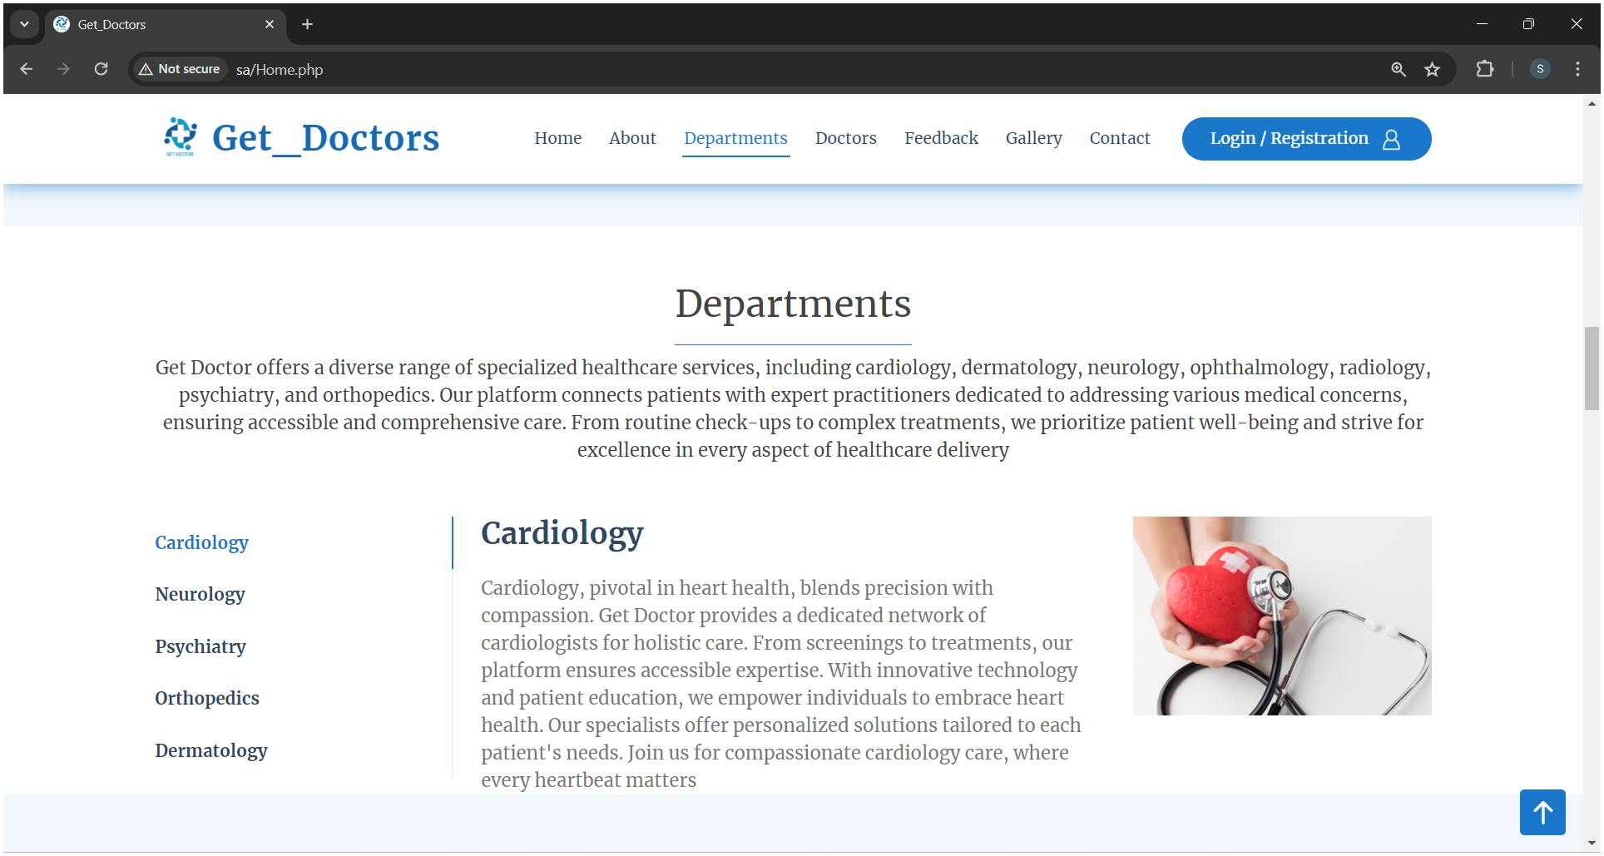

**Doctors**

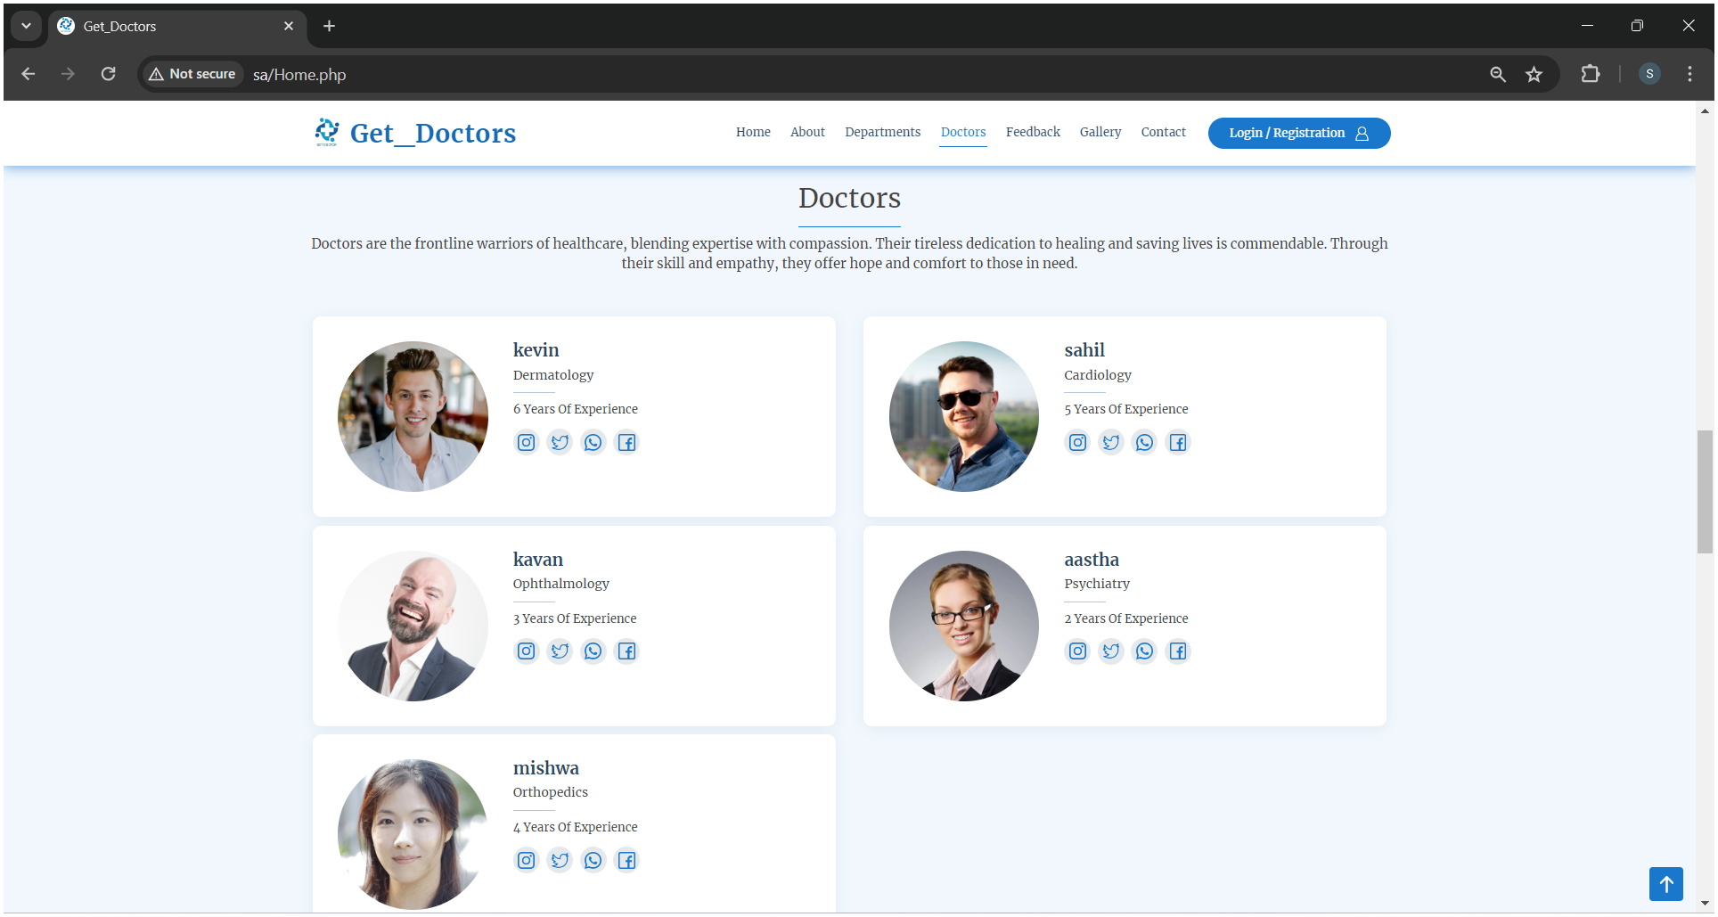

**Feedback**

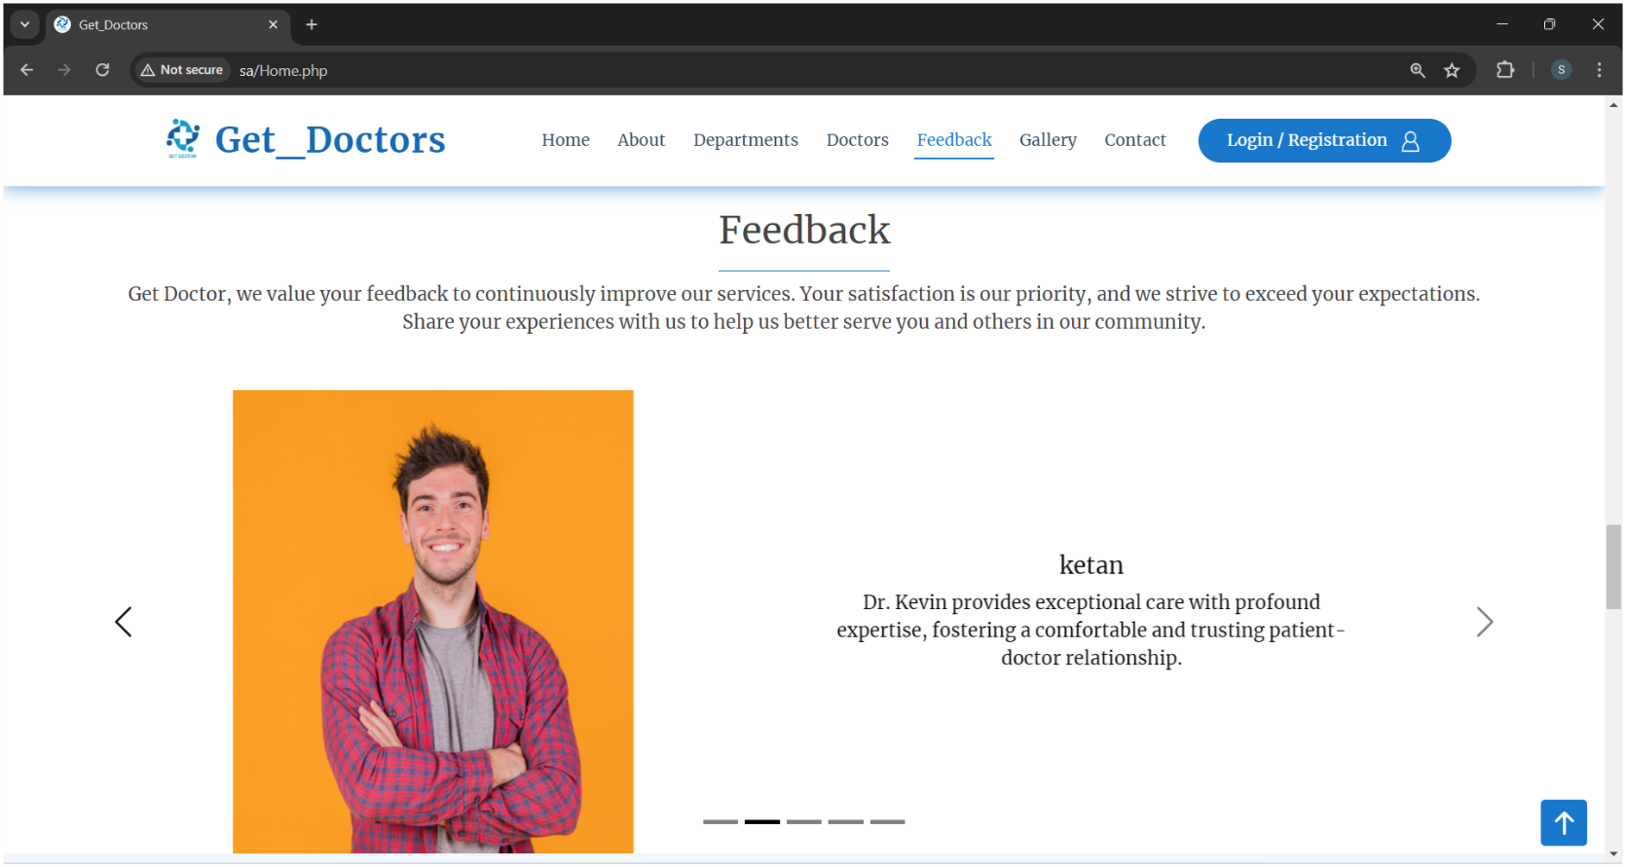

**Gallery**

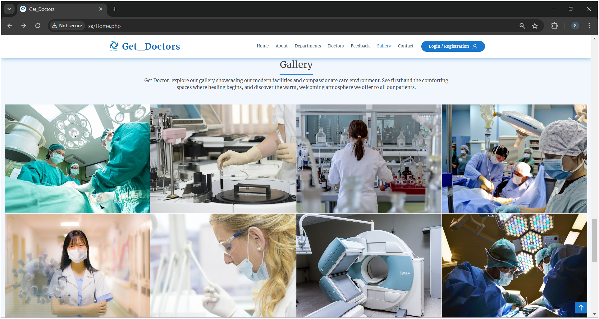

**Contact**

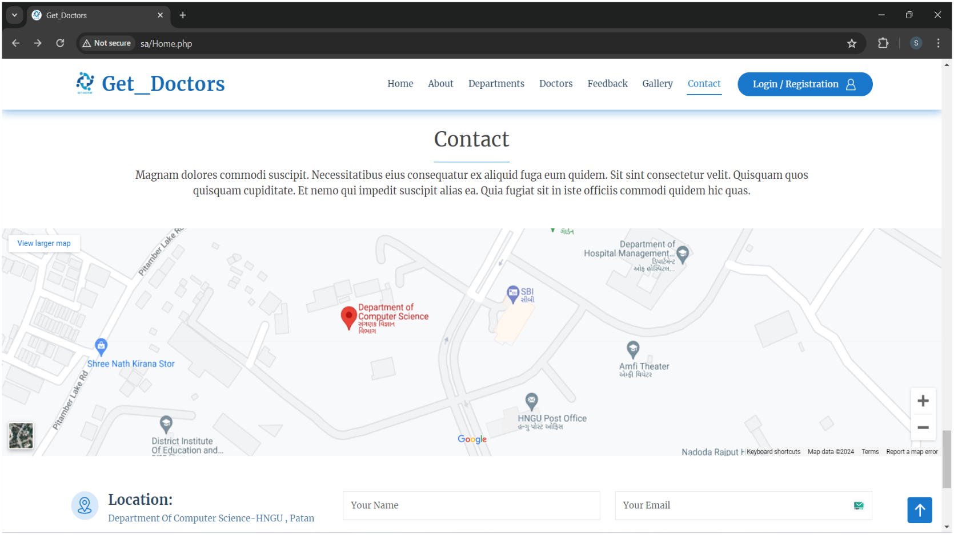

**Contact page scroll up**

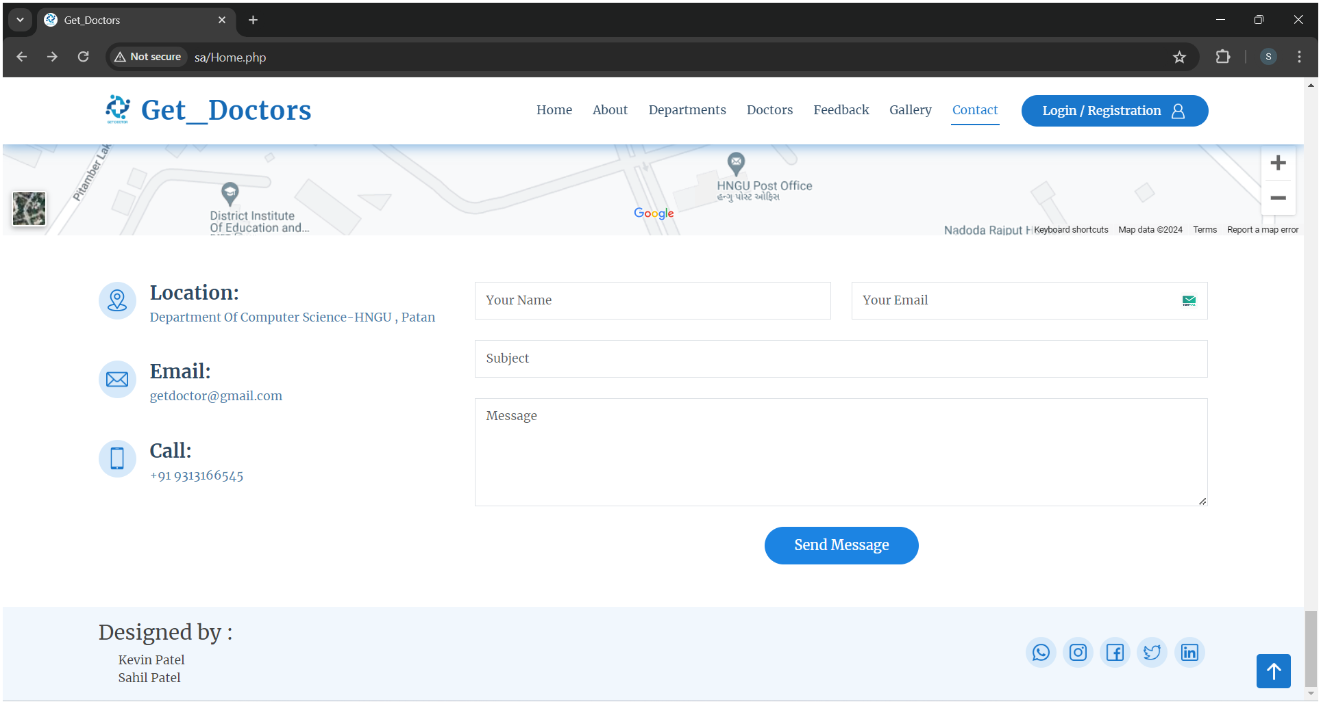

**4.2 :- Patient Module**

**Registration**

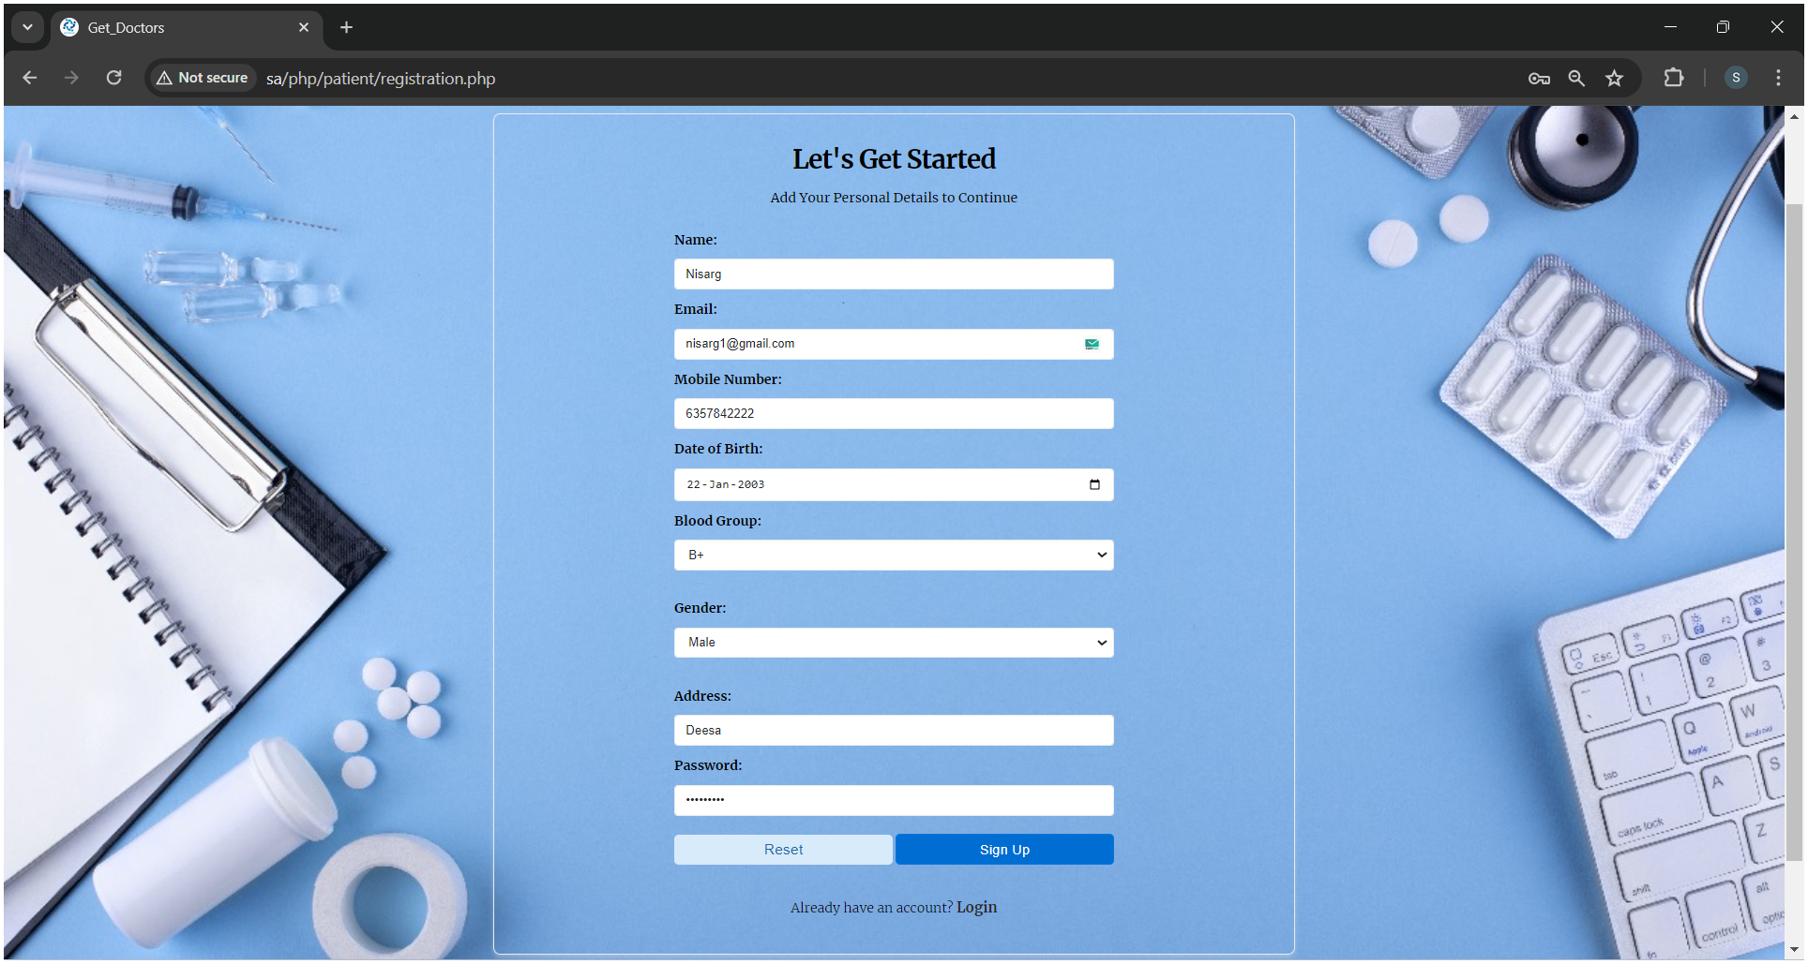

**Login**

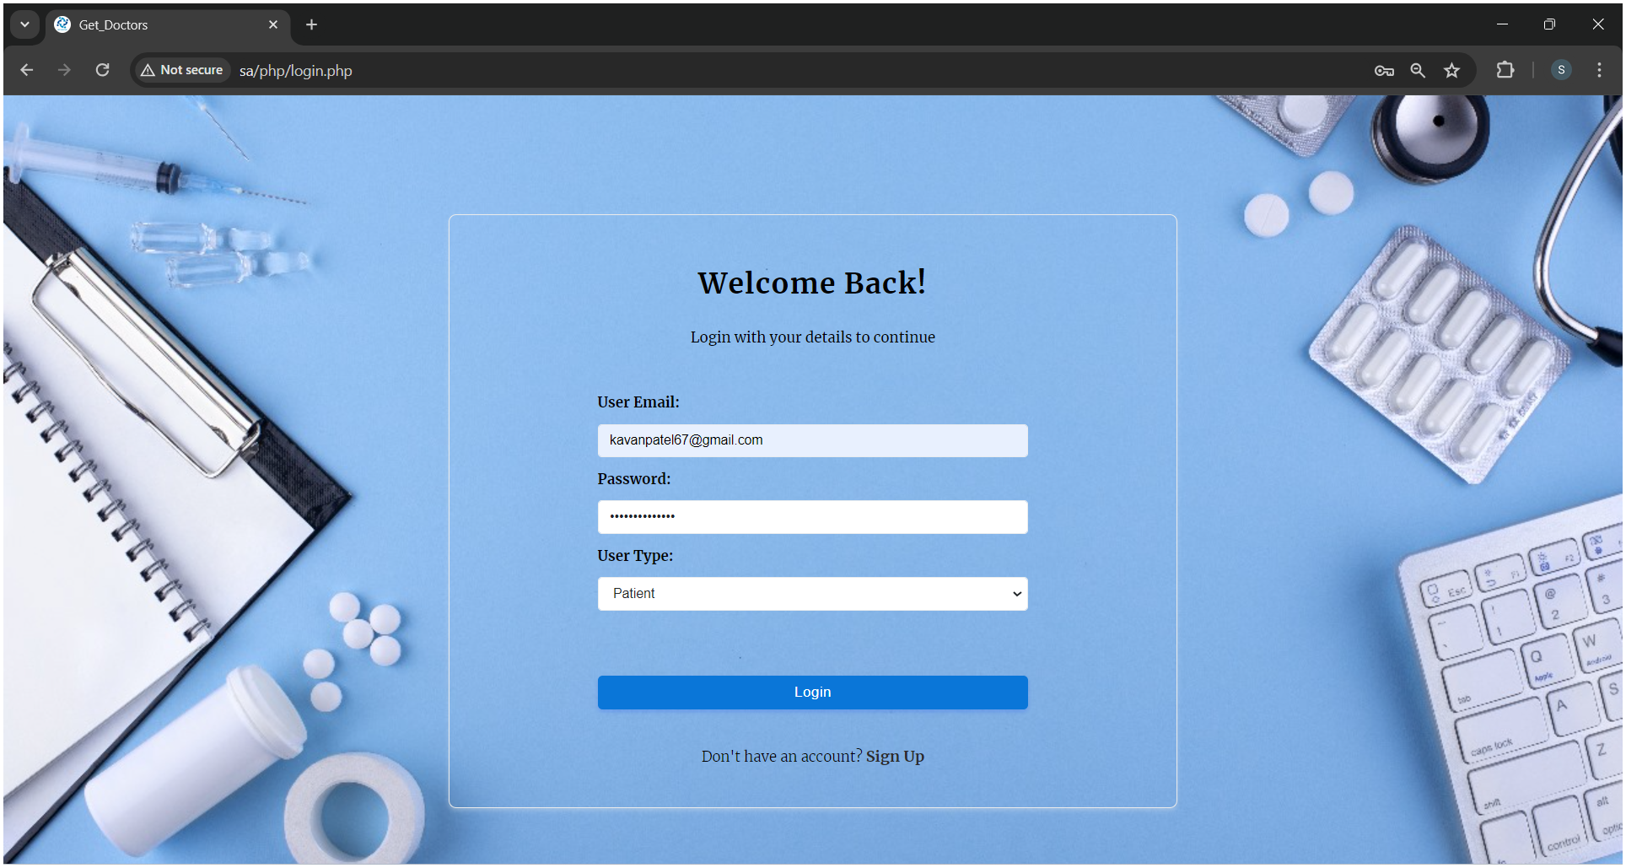

**Home**

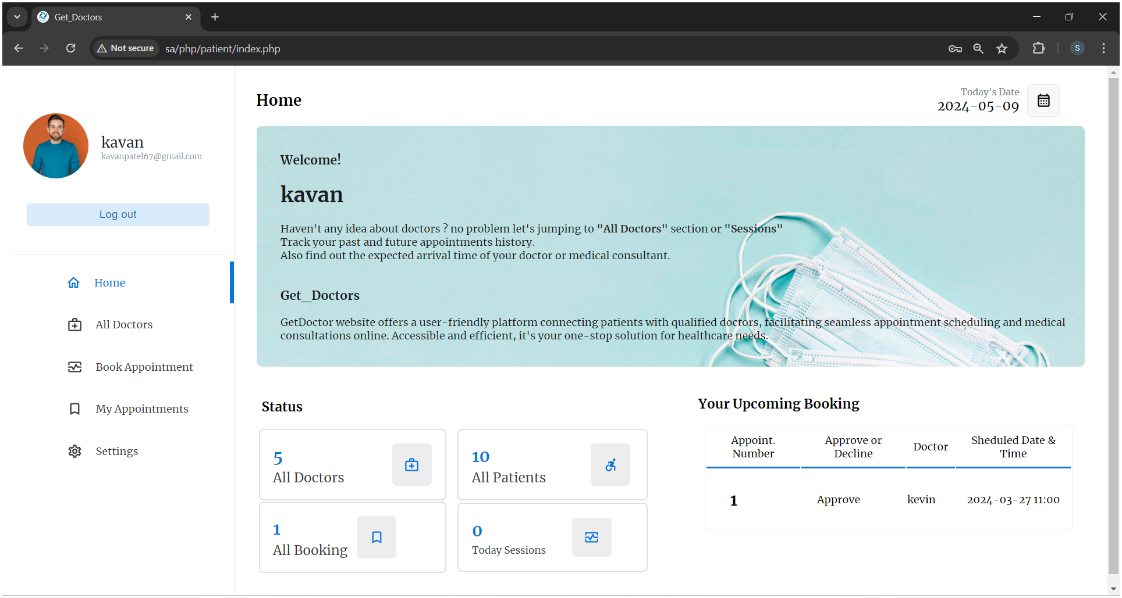

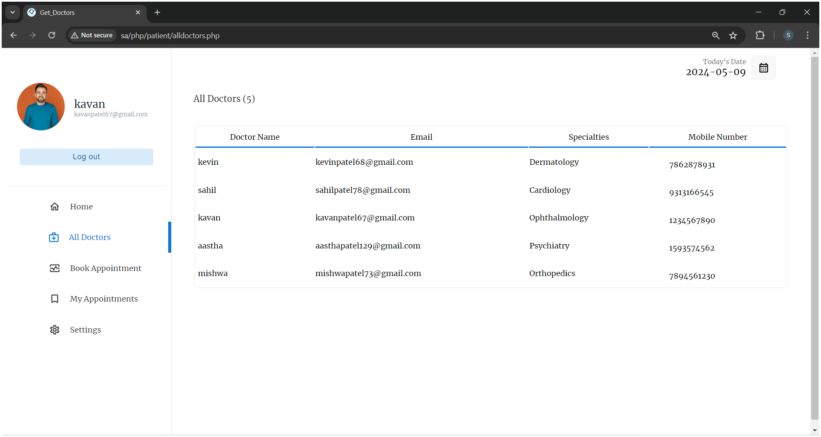

**Show All Doctors**

**Appointment Booking**

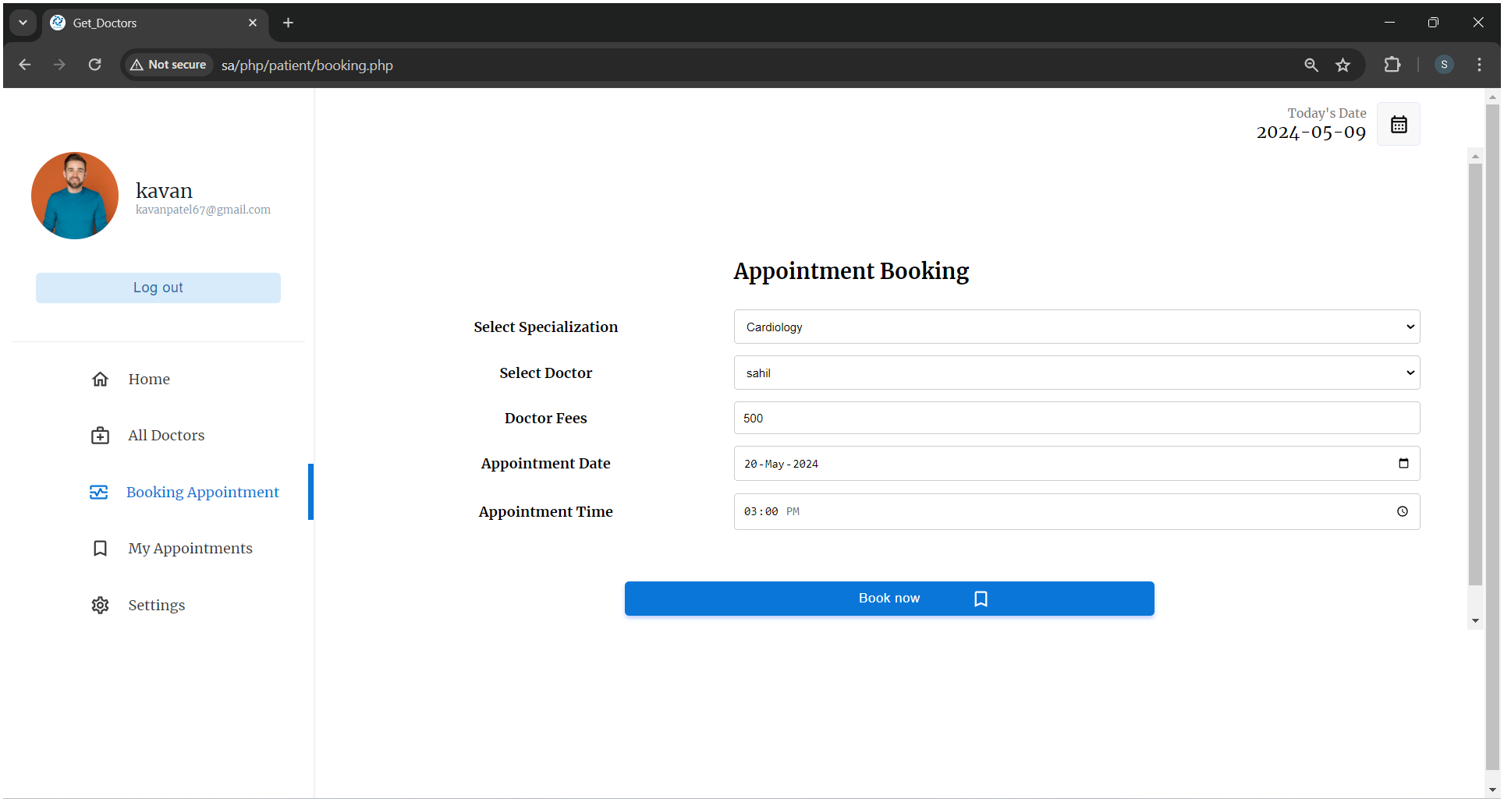

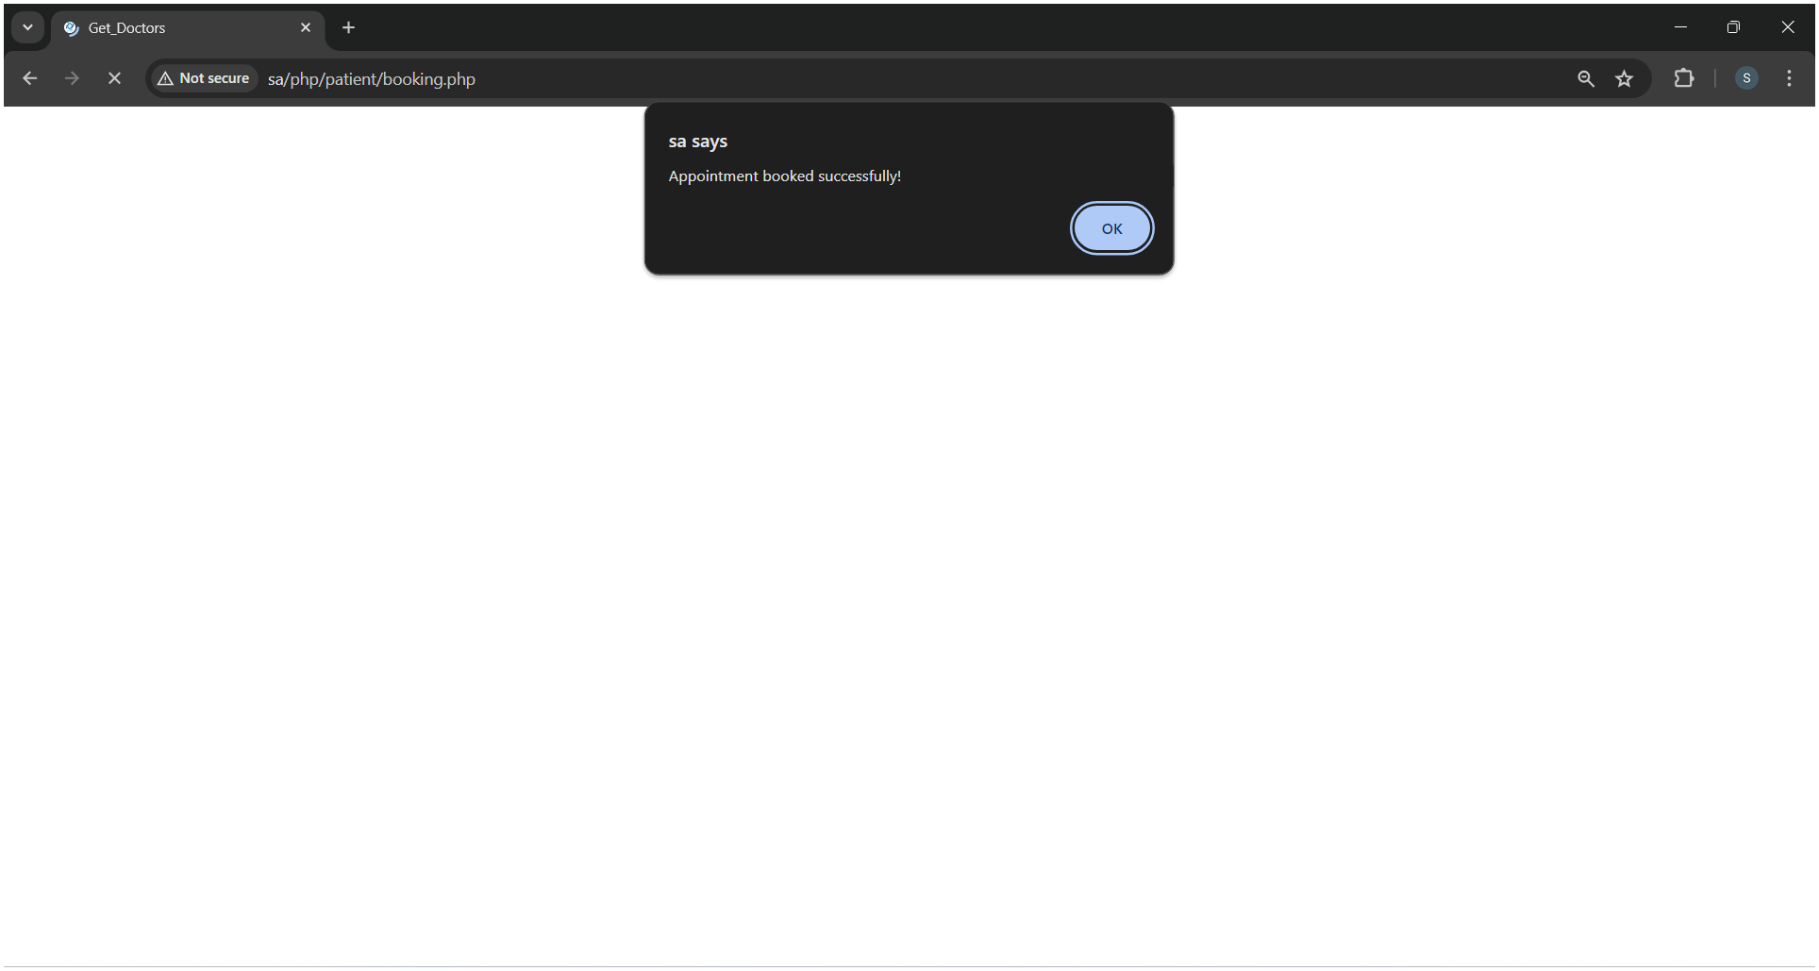

**Appointment Booked Successfully**

**My Appointments**

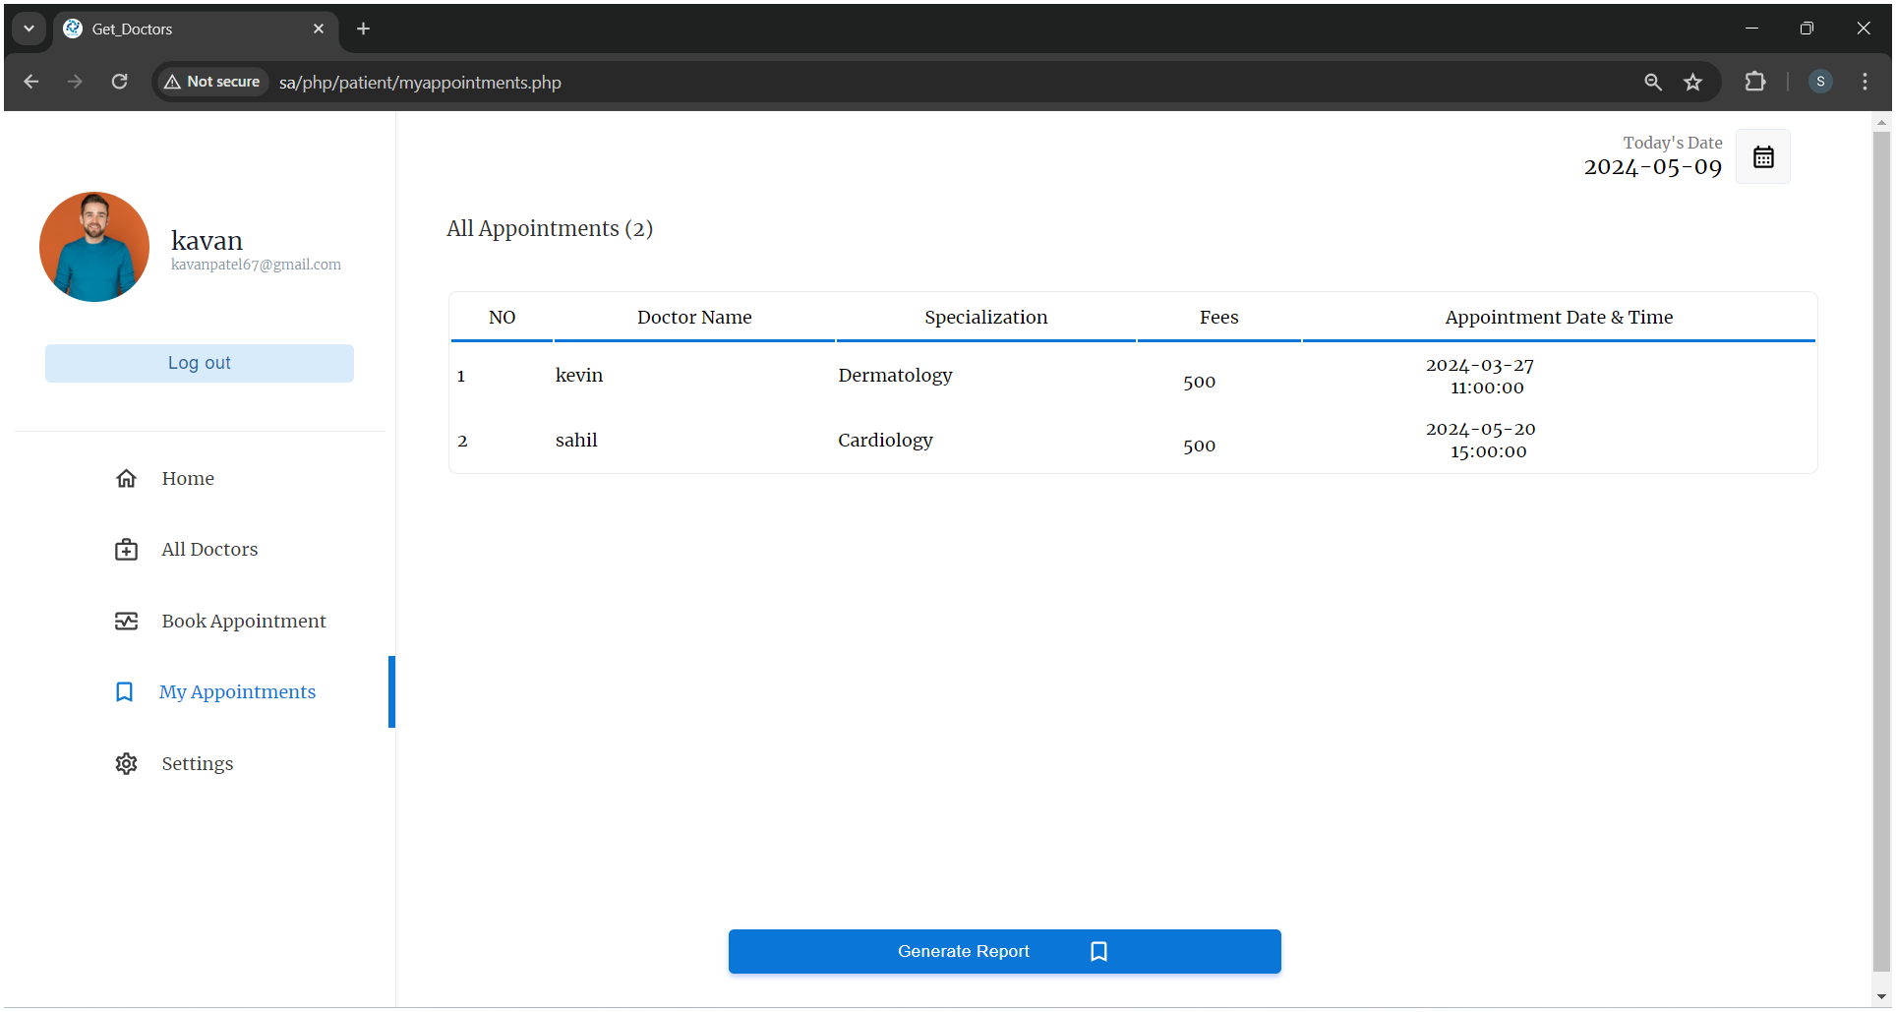

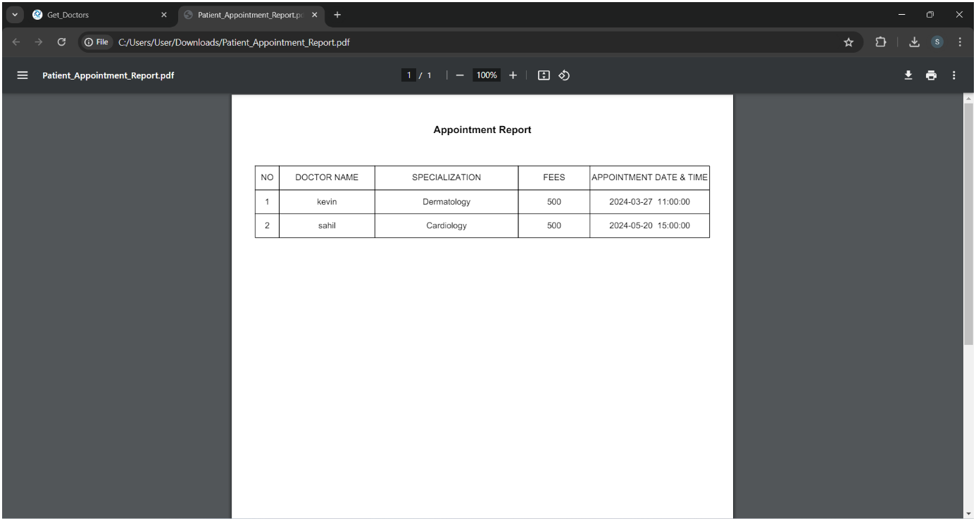

**Appointment Report**

**Setting**

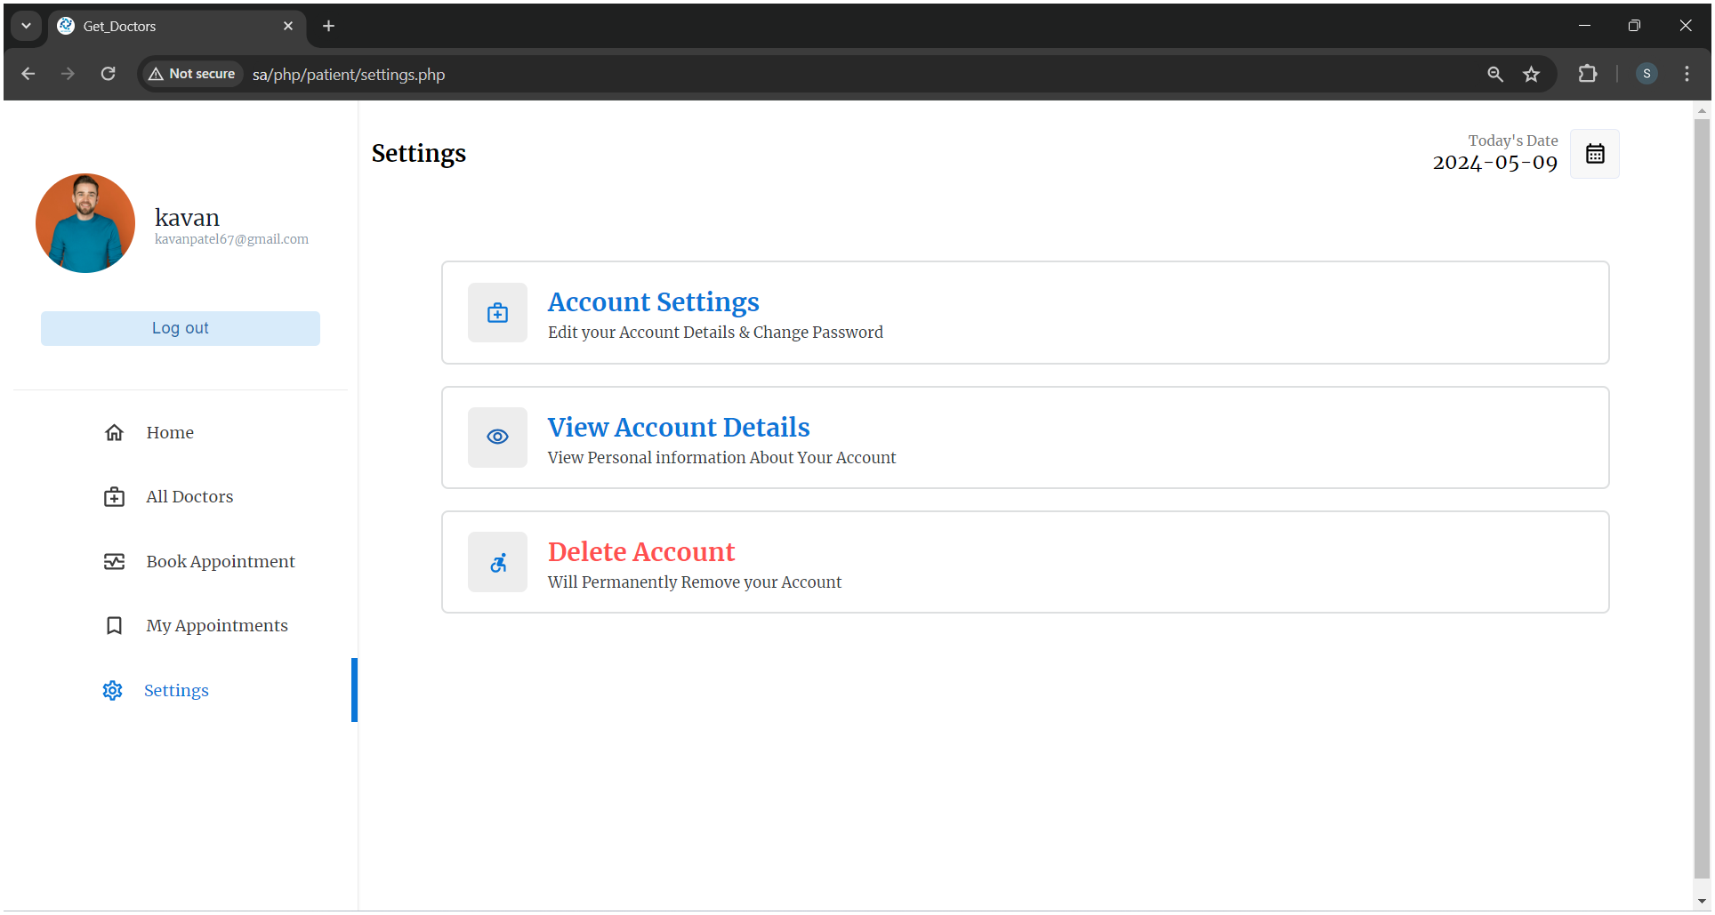

**Edit Account Details**

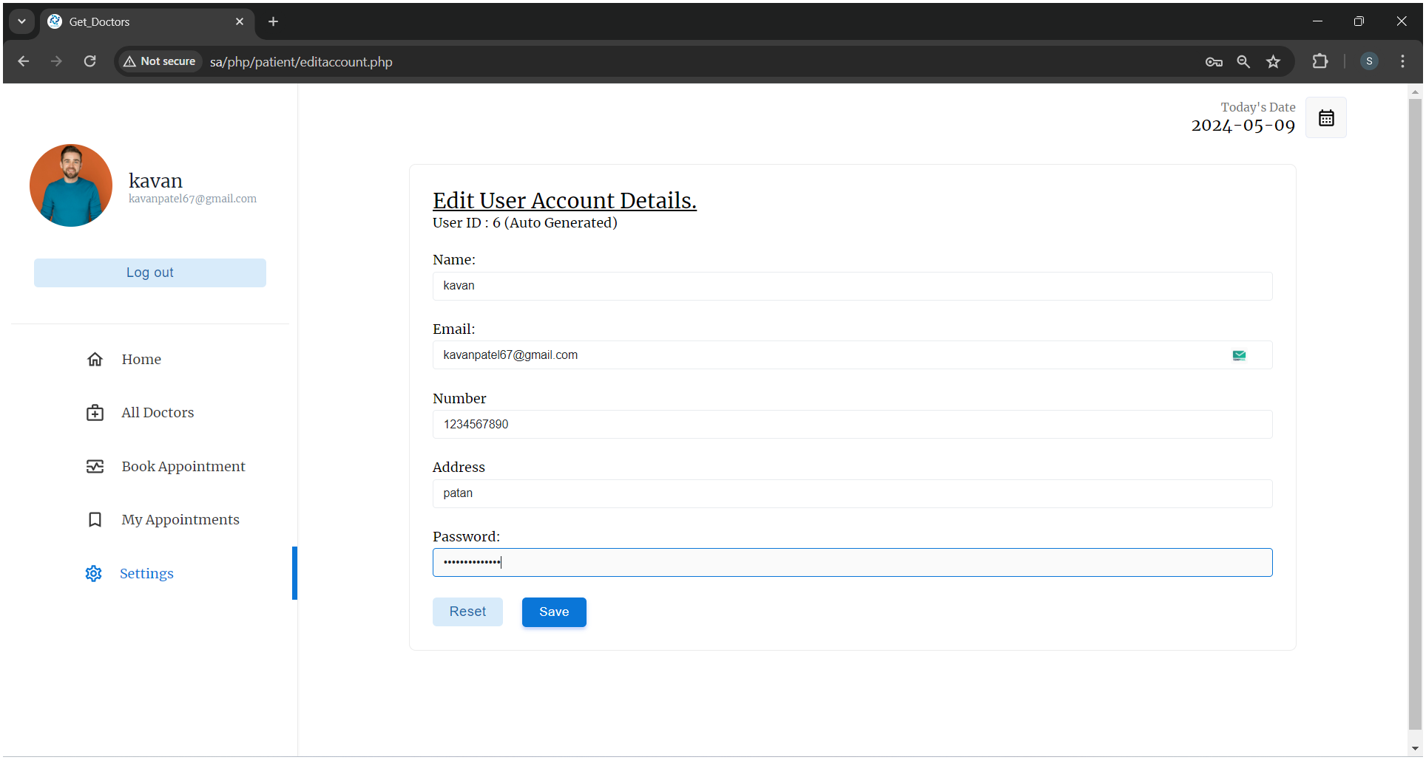

**View Account Details**

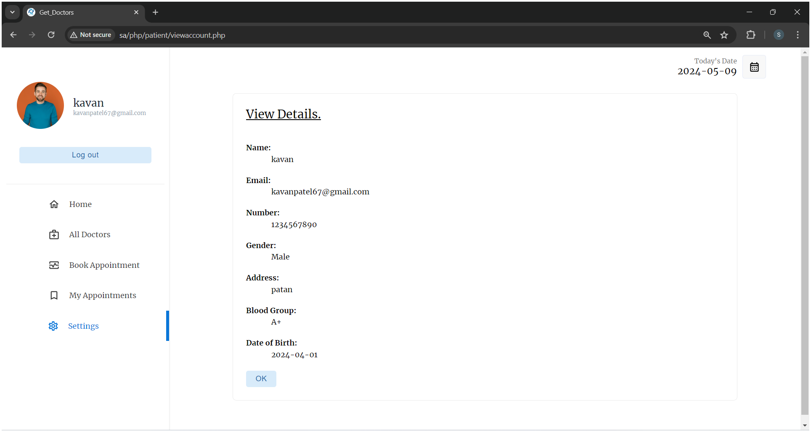

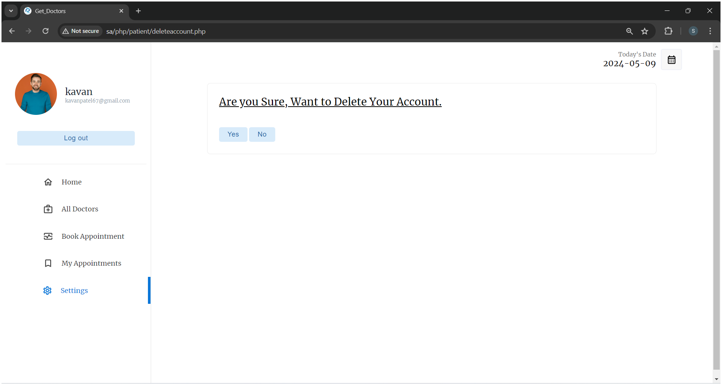**Delete Account**

**4.3 :- Doctor Module**

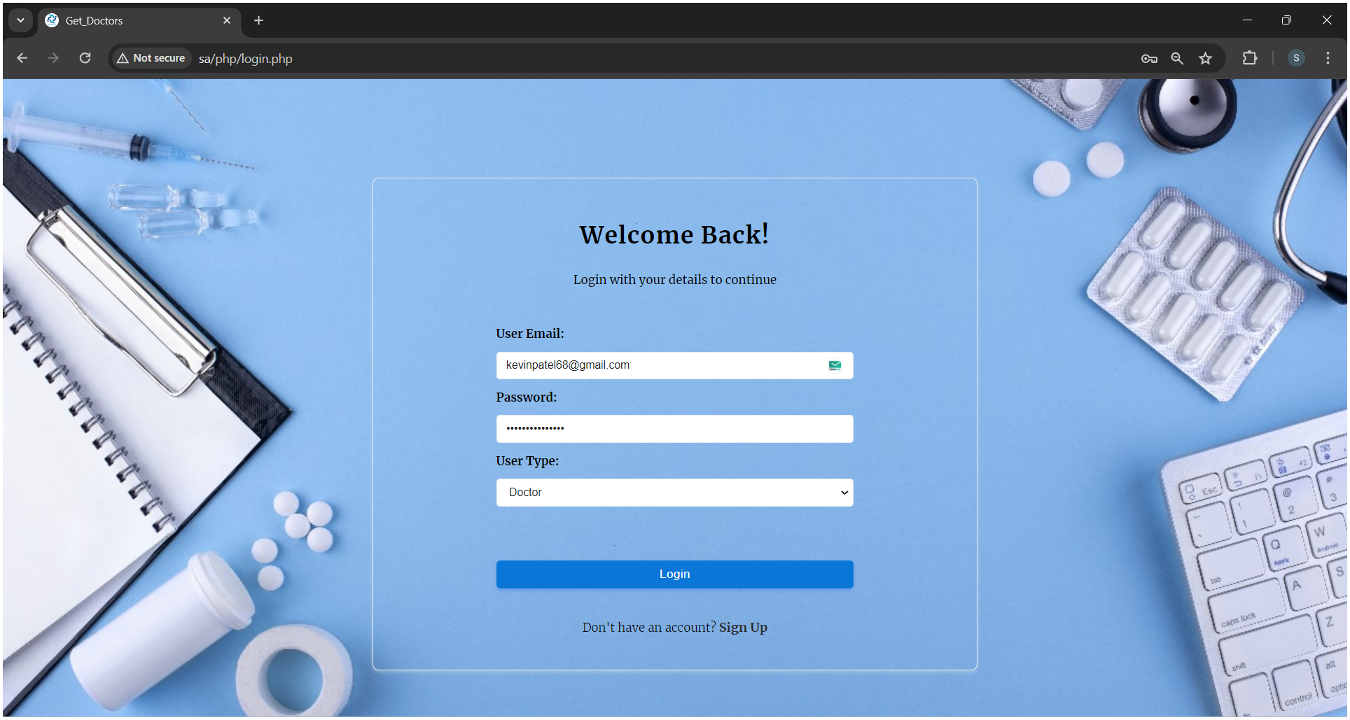**Login**

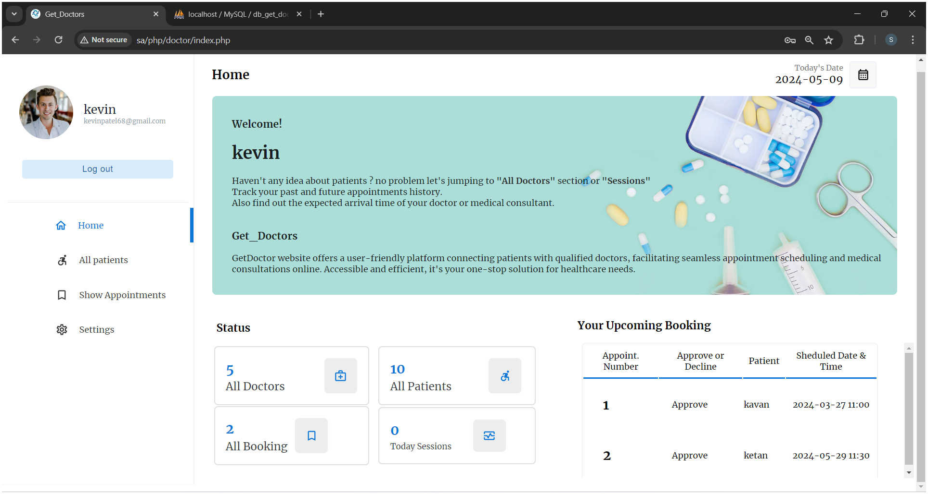**Home**

**Show All Patients**

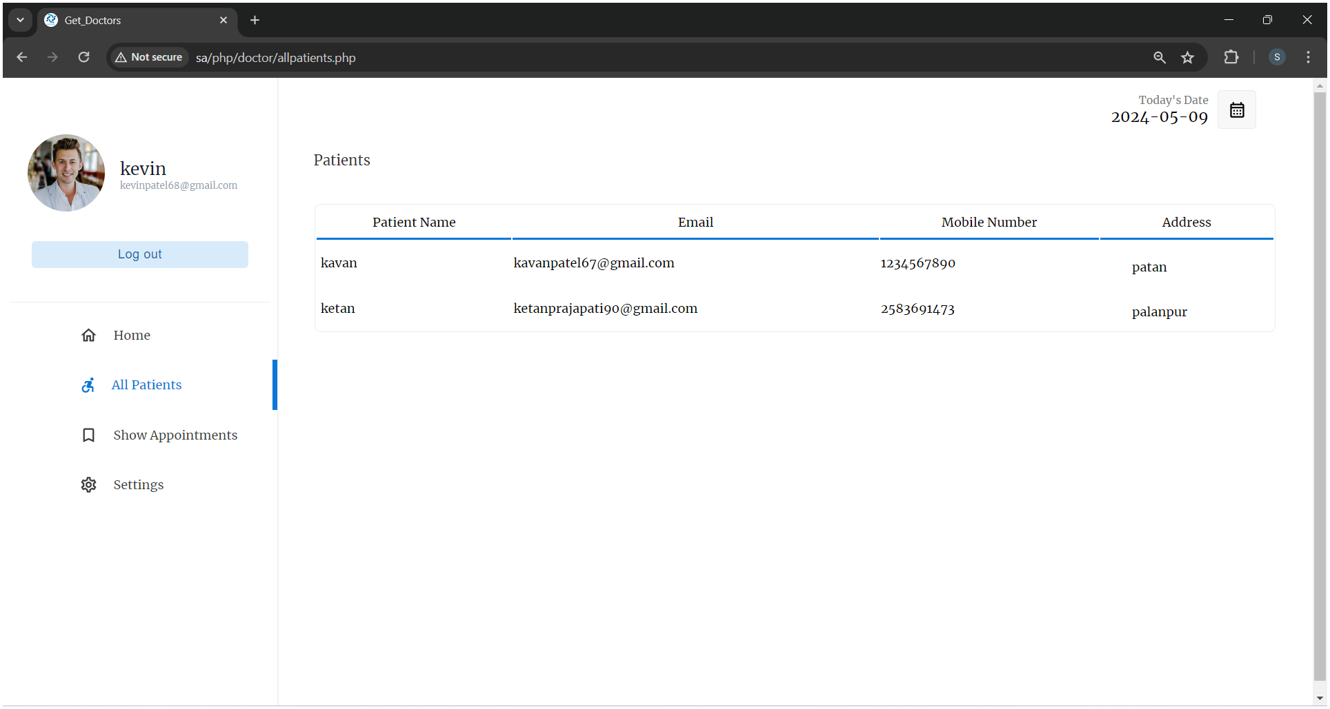

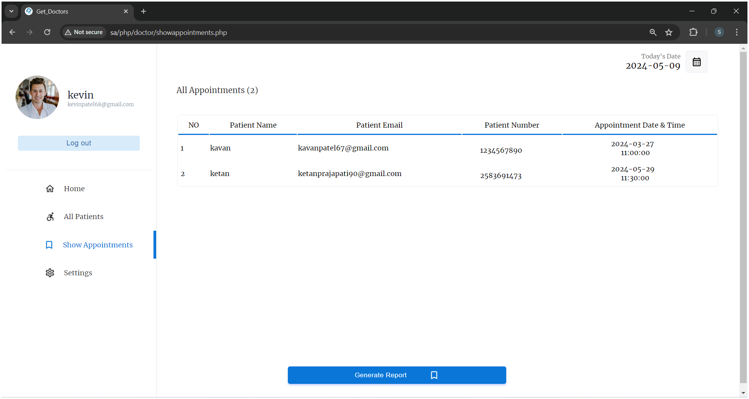**Show All Appointments**

**Appointments Report**

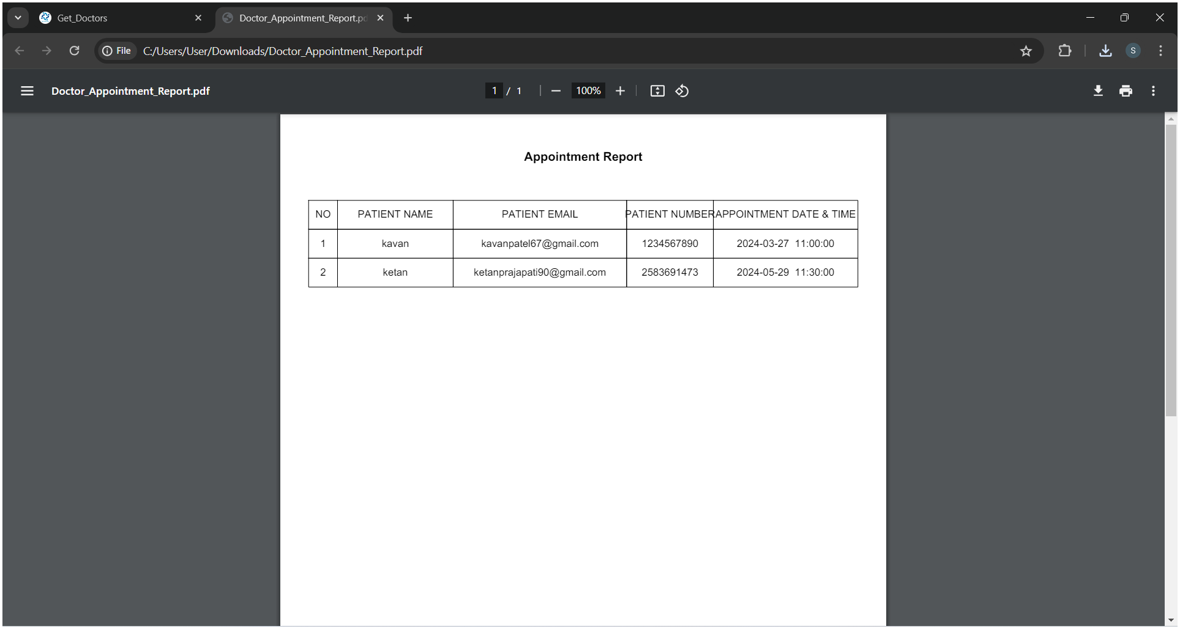

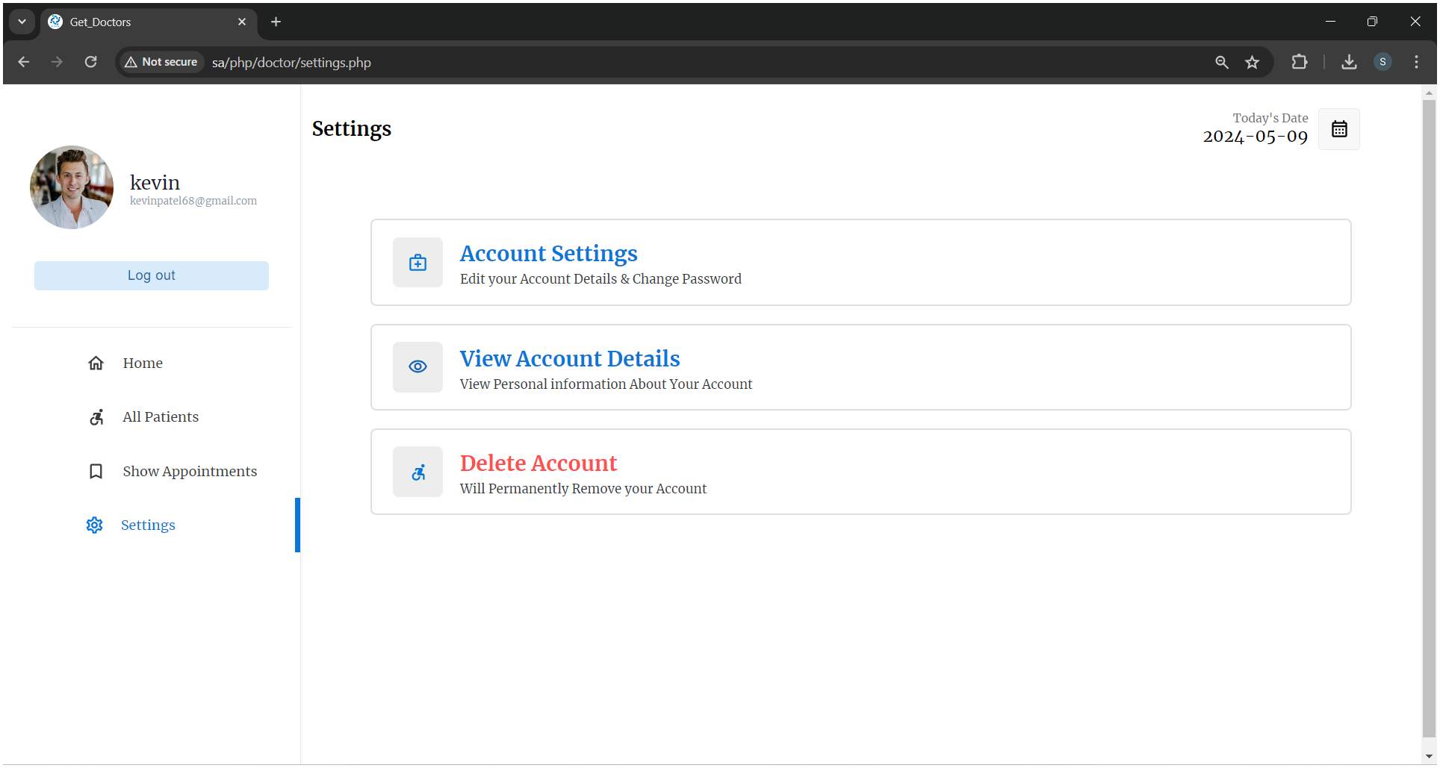**Settings**

**Edit Account Details**

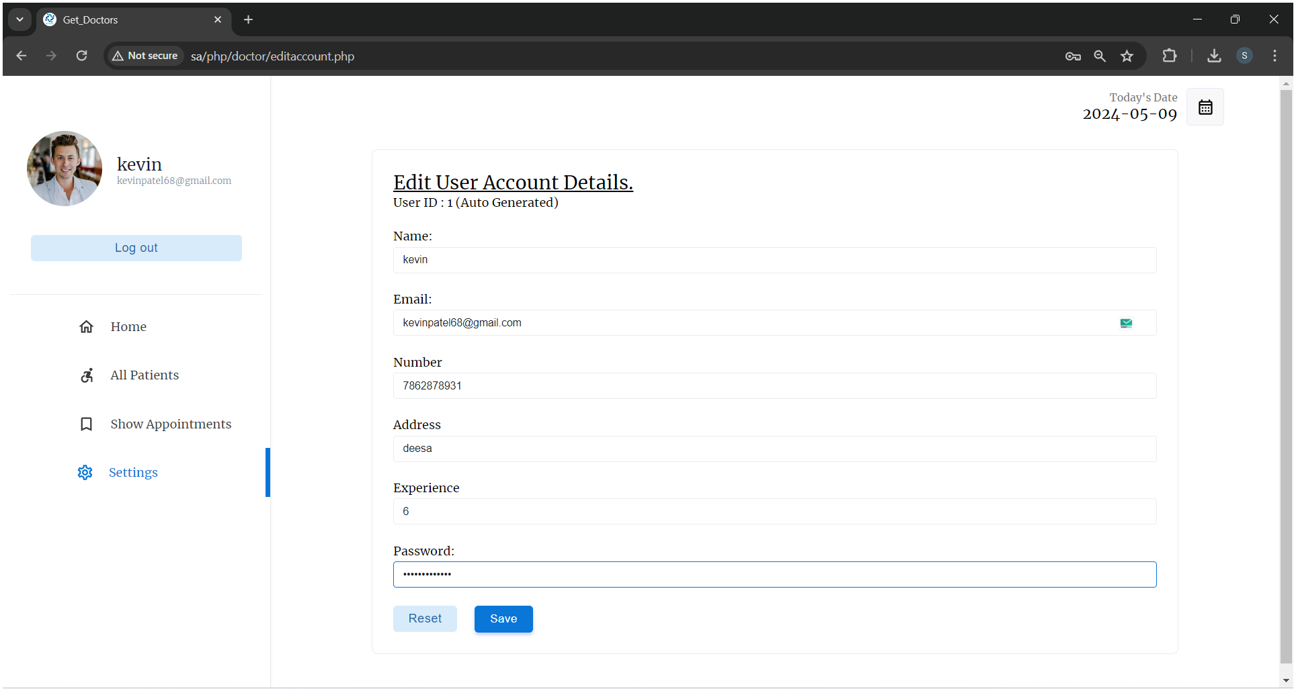

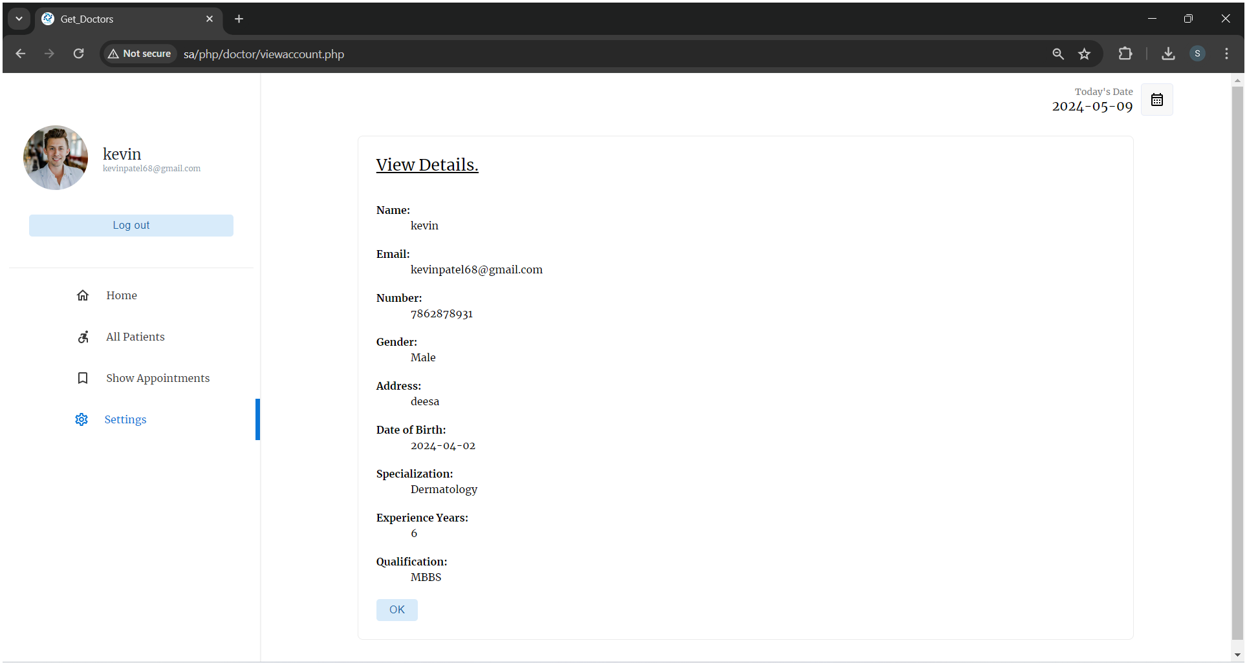

**View Account Details**

**Delete Account**

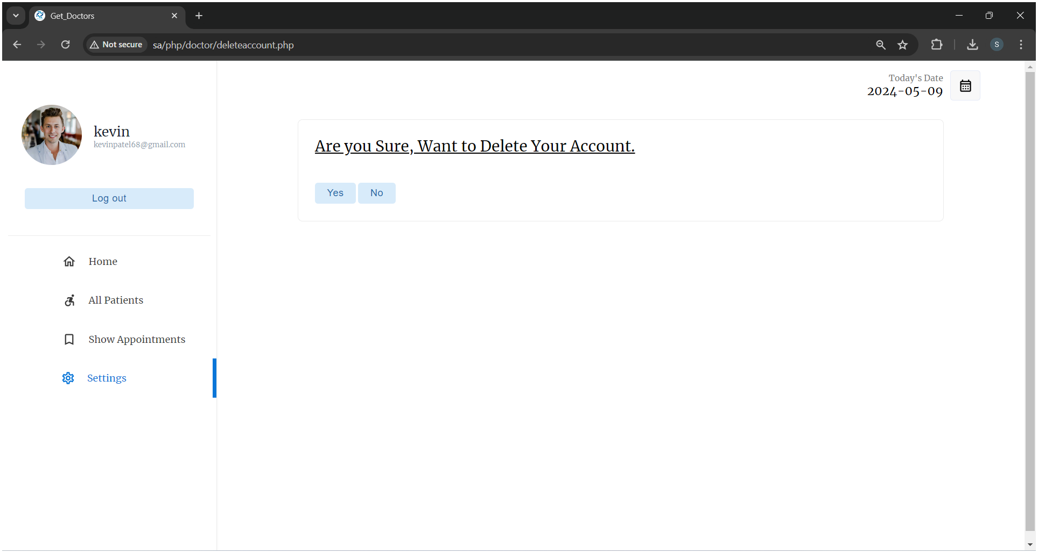

**4.3 :- Admin Module**

**Login**

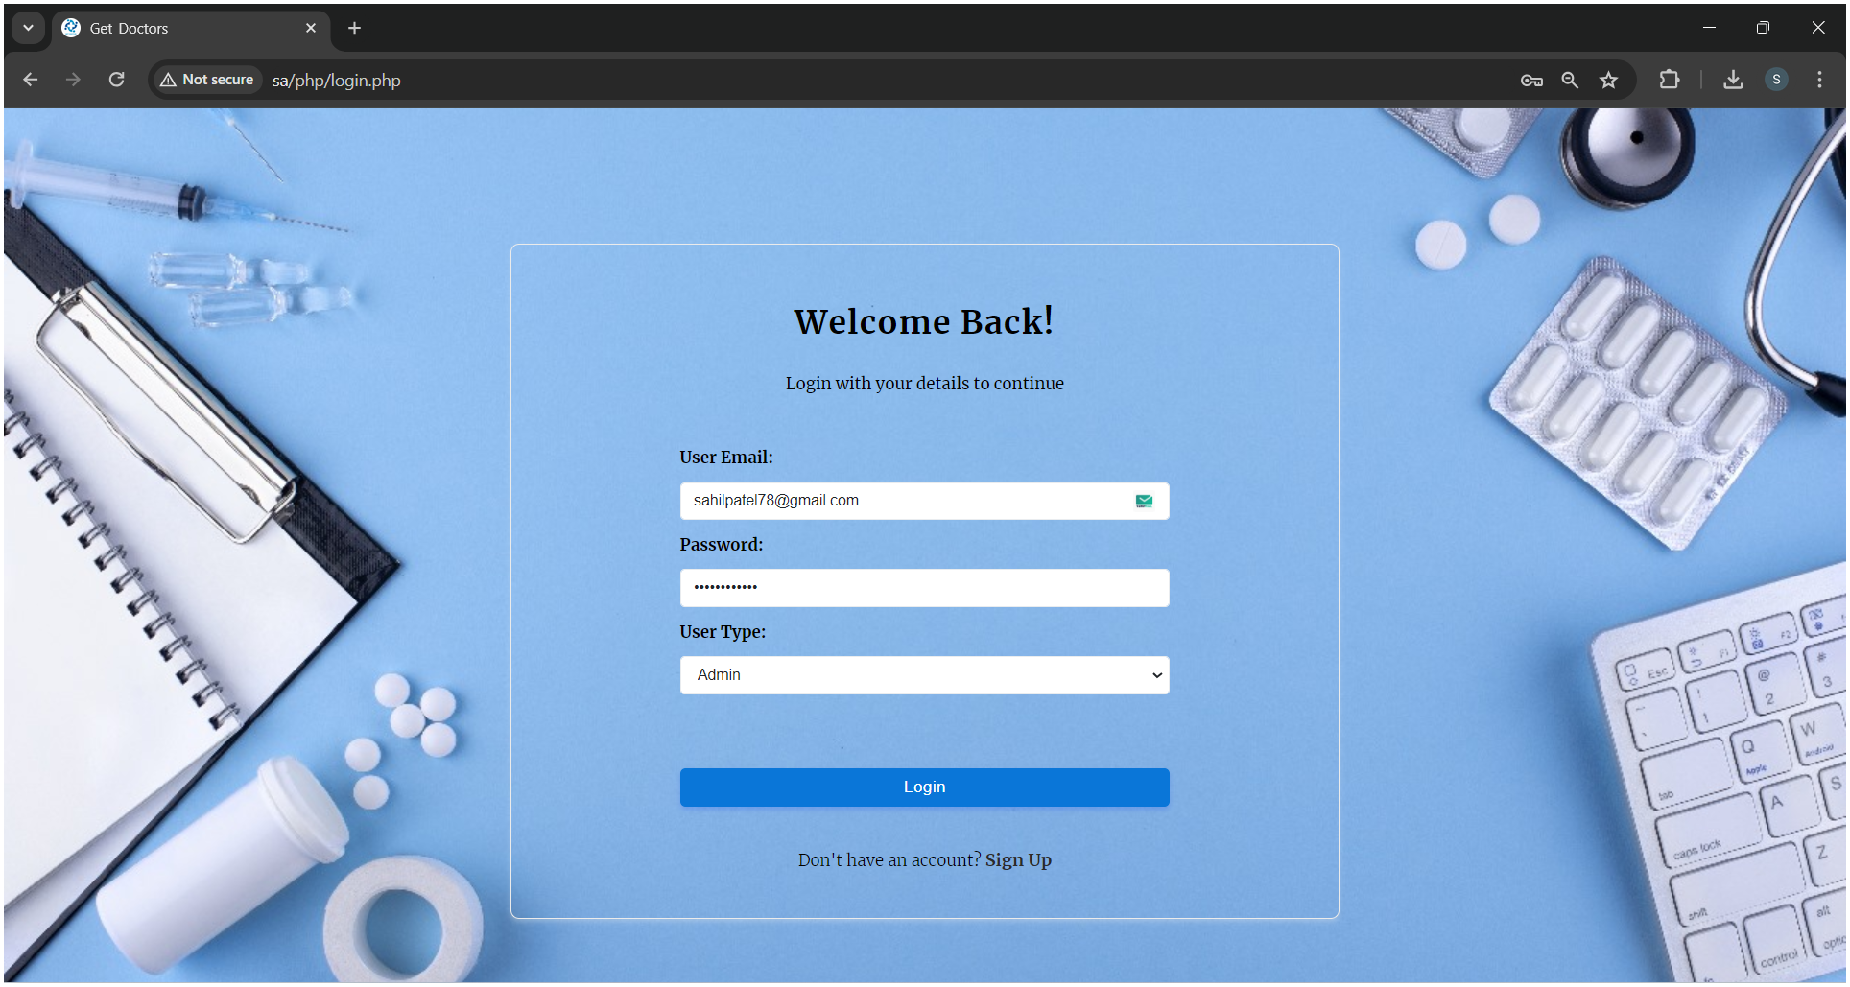

**Home**

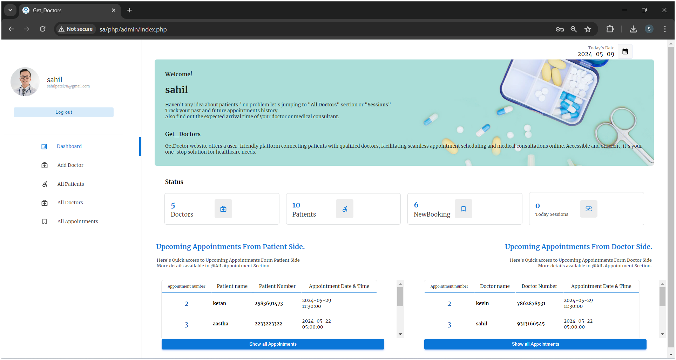

**Add Doctor**

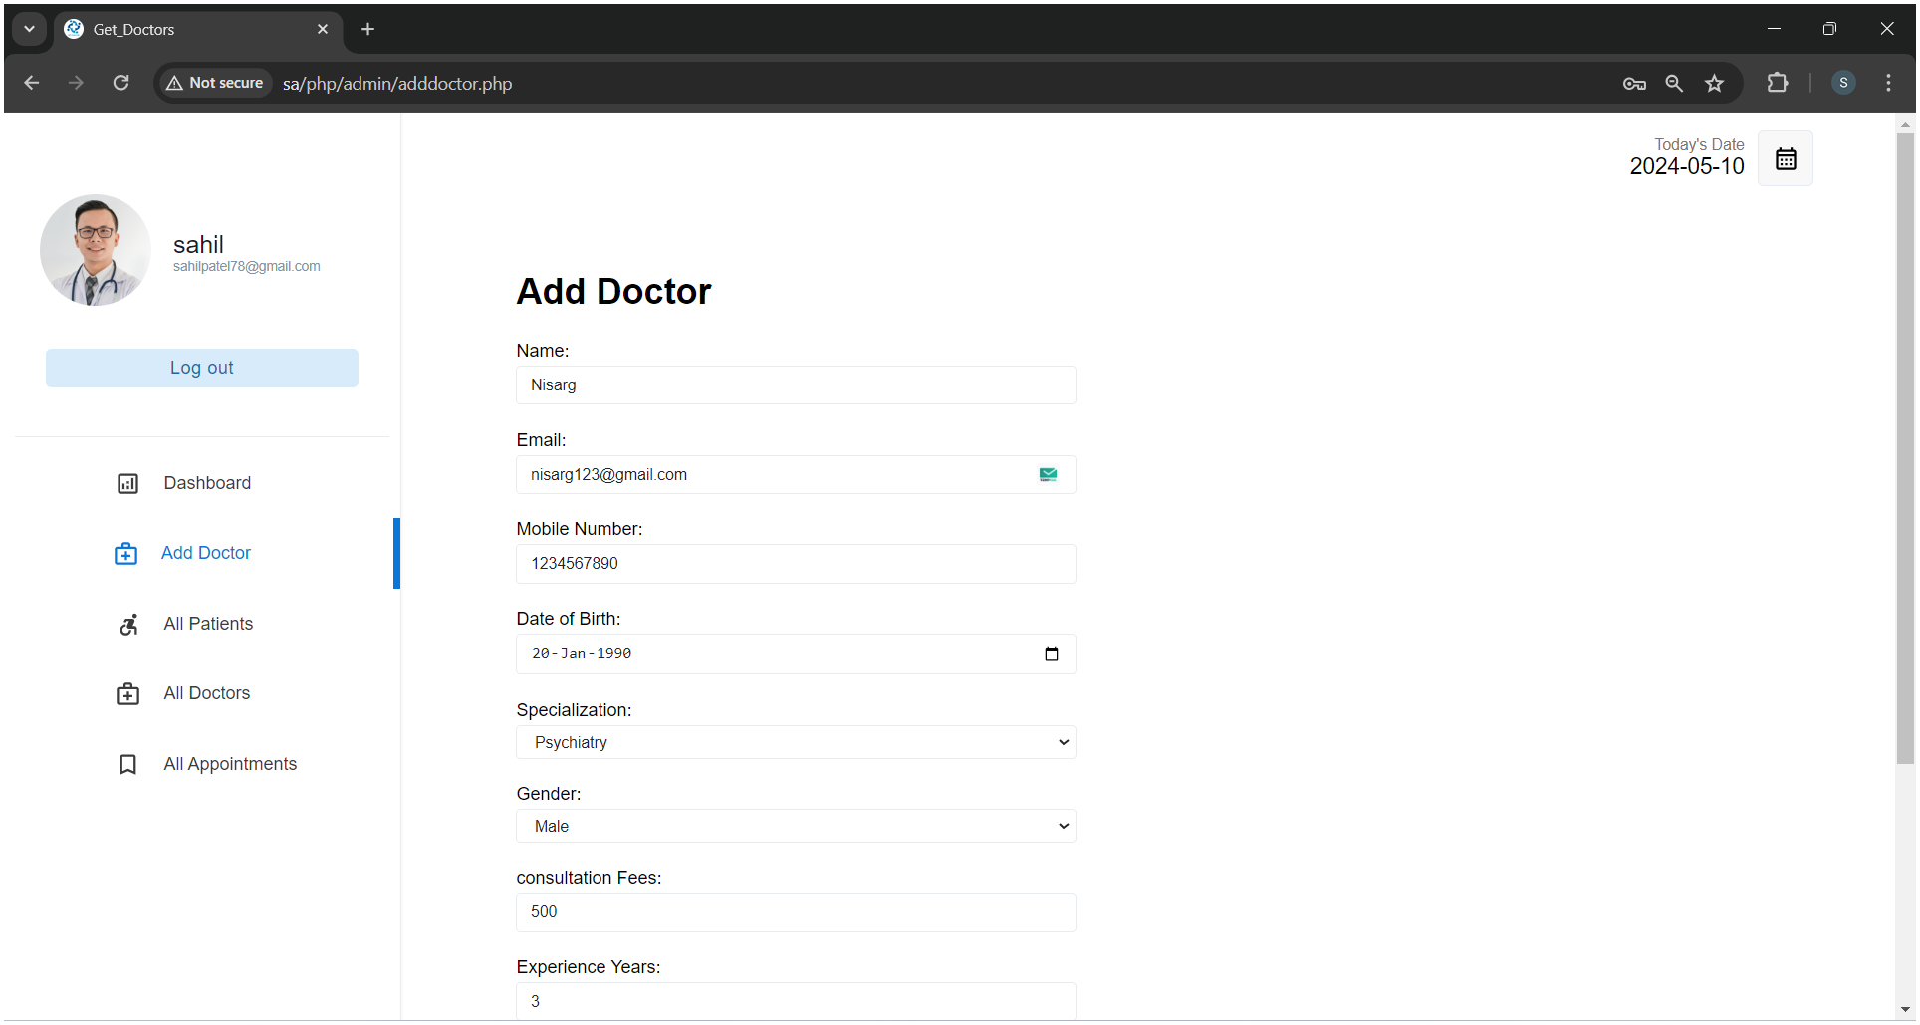

**Add Doctor Scroll up**

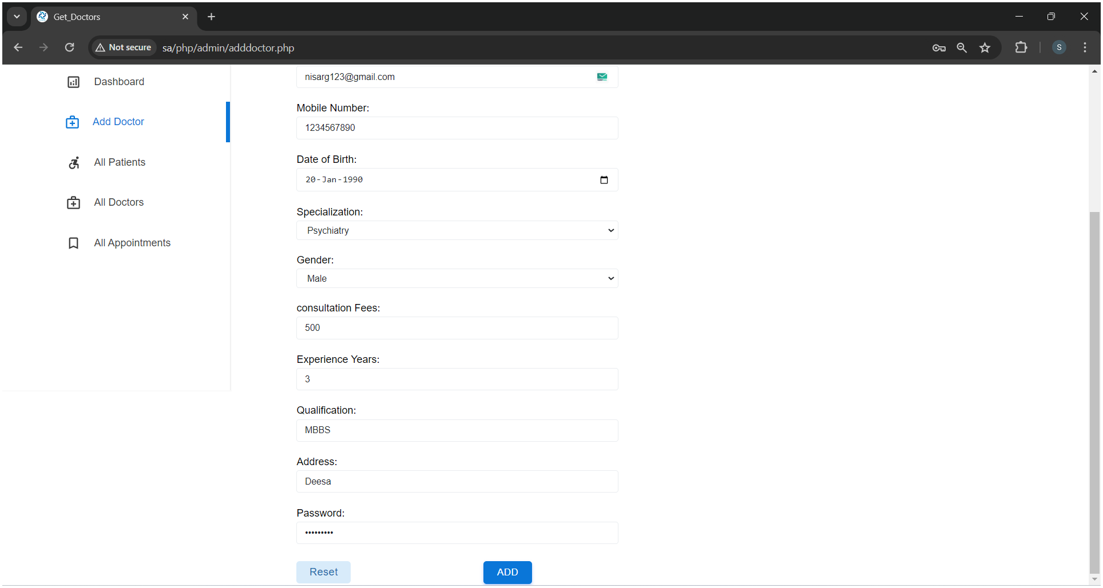

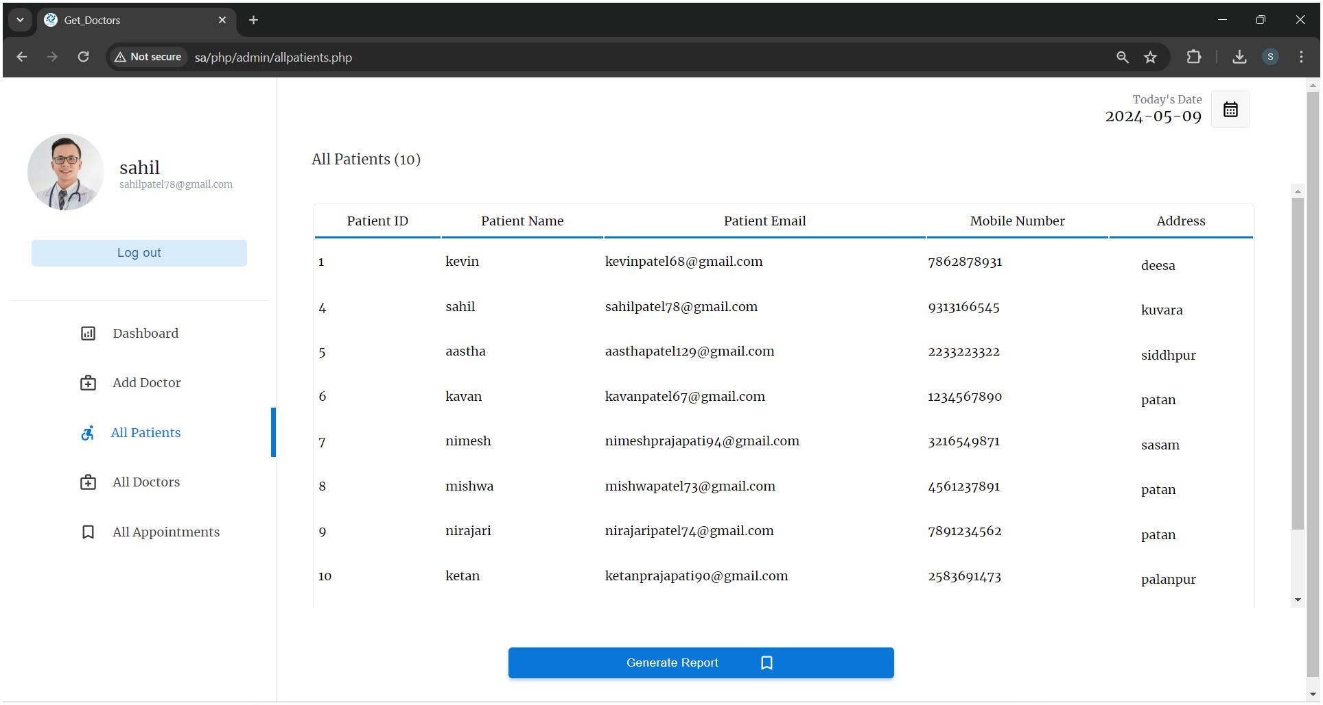

**All Patients**

**All Patients Report Generate**

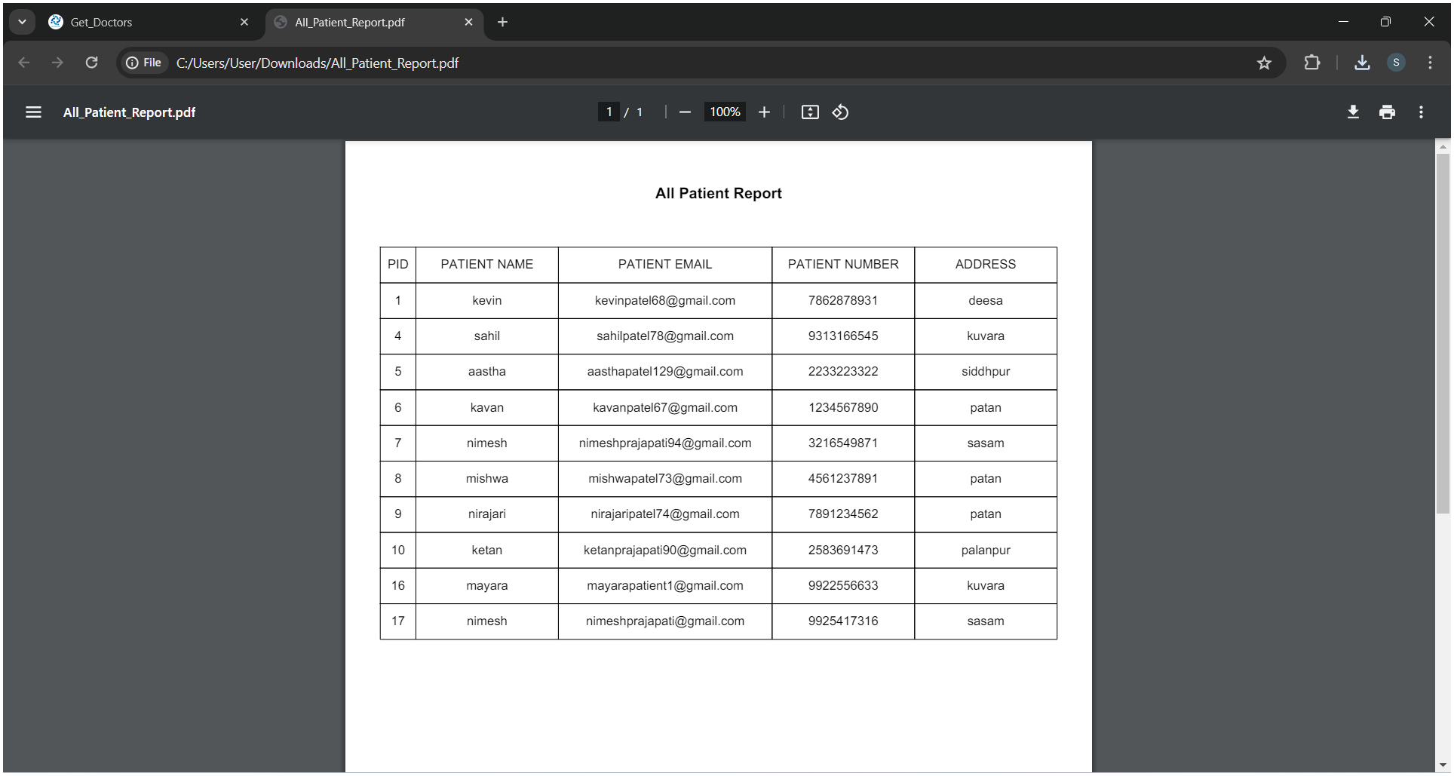

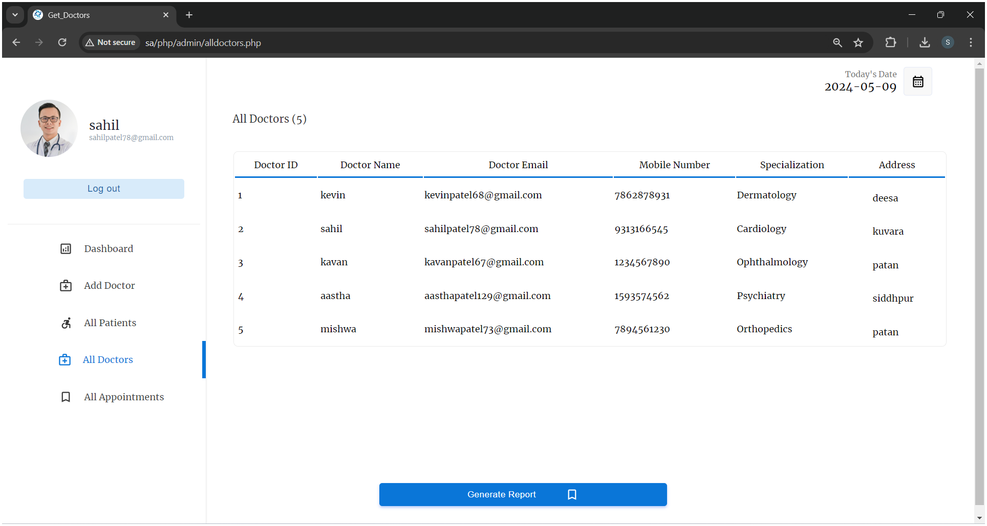

**All Doctors**

**All Doctors Report Generate**

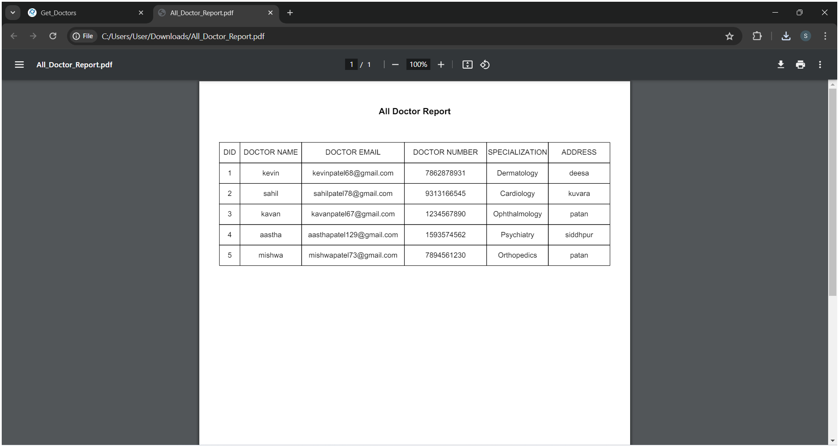

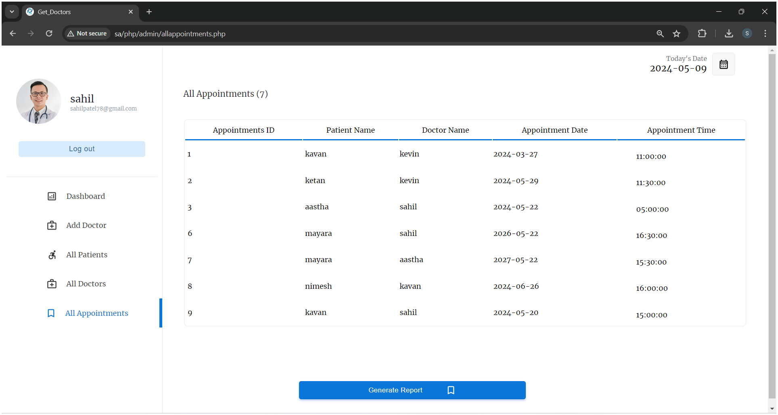

**All Appointments**

**All Appointments Report Generate**

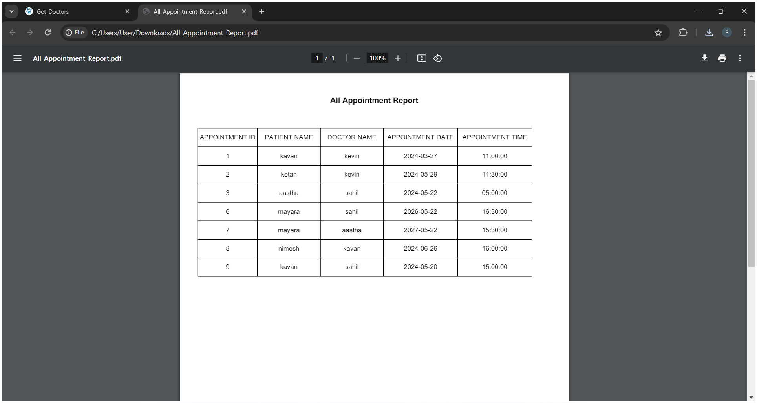

**Chapter 5 🡺 Conclusion & Future Work**

**Conclusion :-**

The "Get Doctor" project presents a transformative solution to address existing challenges in healthcare delivery by leveraging telemedicine technology. Through remote consultations, streamlined appointment scheduling, and enhanced accessibility, the project aims to improve patient access to medical care, optimize resource utilization, and enhance the overall patient experience. By embracing innovation and responding to the evolving healthcare landscape, the project has the potential to revolutionize healthcare delivery and positively impact the well-being of individuals worldwide.

**Future Work :-**

Moving forward, further enhancements and expansions can be considered to maximize the impact and reach of the "Get Doctor" project. This may include:

1. Continued Innovation : Constantly evolving the platform to incorporate new technologies and features that improve user experience, expand service offerings, and adapt to emerging healthcare trends.

2. Strategic Partnerships : Collaborating with healthcare providers, insurance companies, government agencies, and technology partners to broaden the platform's reach, enhance integration with existing healthcare ecosystems, and ensure sustainability.

3. Research and Development : Investing in research initiatives to assess the effectiveness, efficiency, and user satisfaction of the platform, as well as exploring opportunities for integrating artificial intelligence, data analytics, and personalized medicine into the platform's capabilities.

4. Global Expansion : Scaling the project to reach underserved populations in different regions and countries, addressing diverse healthcare needs and cultural considerations, while complying with relevant regulatory requirements.

5. Community Engagement : Engaging with communities to raise awareness about telemedicine benefits, promote health literacy, and empower individuals to take proactive steps towards their health and well-being.

By pursuing these avenues for future work, the "Get Doctor" project can continue to evolve and make significant contributions towards improving healthcare accessibility, efficiency, and outcomes on a global scale.

**Chapter 6 🡺 References**

**Websites :-**

[**www.askapollo.com**](http://www.askapollo.com)

[**www.apollo247.com**](http://www.apollo247.com)